Supplement Information

Supplement I

In this supplement, we include detailed measurements of environmental variables in each sampling layer in each sampling site. The environmental variables include depth (m) of water sampling, temperature (*Temp*, ℃), salinity (*Sal*, ‰), the concentration of chlorophyll-a (*Chla*; µg/L), dissolved inorganic nitrogen (*DIN*: NO2+NO3, µM), and phosphate (*P*, µM). For the concentration of chlorophyll-a, the detection limit is 0.01 µg/L. For dissolved inorganic nitrogen and phosphate, the detection limit is 0.01 µM. Nutrient concentrations under detection limit (*Chla* < 0.01 µg/L; *DIN <* 0.01 µM; *P* <0.01 µM) are calculated as minimum detection limit. Note that in station StTS1, the deep chlorophyll-a maximum layer (DCM) and the surface layer are at the same depth (5 meters) such that the DCM measurement from station StTS1 is not applicable (NA). Furthermore, we provide the correlation among diversity indexes and predictors. Measurements of these environmental variables were included below in Table S1 and deposited with links to BioProject accession number PRJNA798158 in the NCBI BioProject database (https://www.ncbi.nlm.nih.gov/bioproject/).

Table S1. Measurements of environmental variables in each sampling site.

|  |  |  |  |  |  |  |  |  |  |  |  |
| --- | --- | --- | --- | --- | --- | --- | --- | --- | --- | --- | --- |
| Station ID | Surface layer | | | | | Deep chlorophyll-a maximum layer | | | | | |
| *Temp.* | *Sal.* | *Chla* | *DIN* | *P* | *Depth* | *Temp.* | *Sal.* | *Chla* | *DIN* | *P* |
| StBS1 | 23.87 | 34.72 | 0.41 | 0.20 | 0.01 | 30 | 23.88 | 34.72 | 0.49 | 0.16 | 0.01 |
| StBS3 | 24.33 | 34.73 | 0.33 | 0.16 | <0.01 | 70 | 24.34 | 34.73 | 0.37 | 0.14 | <0.01 |
| StBS5 | 23.96 | 34.81 | 0.43 | 0.10 | 0.03 | 70 | 23.97 | 34.81 | 0.35 | 0.07 | 0.03 |
| StOK1b | 24.54 | 34.45 | 0.52 | 0.06 | 0.01 | 71 | 24.88 | 34.65 | 0.55 | 0.12 | 0.02 |
| StOK1 | 23.89 | 34.06 | 0.83 | 0.24 | 0.04 | 25 | 23.95 | 34.13 | 0.63 | 0.37 | 0.03 |
| StOK2 | 26.00 | 34.80 | 0.24 | 0.02 | <0.01 | 94 | 25.18 | 34.85 | 0.30 | 0.22 | 0.03 |
| StOK3 | 26.21 | 34.85 | 0.19 | 0.01 | <0.01 | 82 | 25.65 | 34.87 | 0.30 | 0.28 | 0.04 |
| StOK4 | 26.15 | 34.90 | 0.18 | 0.01 | <0.01 | 101 | 24.96 | 34.90 | 0.22 | 0.42 | 0.05 |
| StOK6 | 25.40 | 34.81 | 0.26 | 0.01 | <0.01 | 85 | 25.33 | 34.80 | 0.29 | 0.02 | <0.01 |
| StTE1 | 26.89 | 34.35 | 0.10 | <0.01 | <0.01 | 56 | 23.78 | 34.82 | 0.78 | 1.25 | 0.12 |
| StTE3 | 27.37 | 34.61 | 0.07 | 0.01 | <0.01 | 97 | 22.18 | 34.88 | 0.34 | 0.87 | 0.06 |
| StTE4 | 28.01 | 34.82 | 0.05 | 0.01 | <0.01 | 105 | 21.46 | 34.89 | 0.37 | 0.96 | 0.06 |
| StTK1 | 25.46 | 34.86 | 0.20 | <0.01 | <0.01 | 67 | 25.48 | 34.86 | 0.24 | 0.01 | 0.01 |
| StTK3 | 25.84 | 34.80 | 0.23 | <0.01 | <0.01 | 97 | 24.20 | 34.85 | 0.20 | 0.91 | 0.05 |
| StTK6 | 24.23 | 34.74 | 0.53 | 0.10 | 0.01 | 41 | 22.96 | 34.41 | 0.75 | 0.56 | 0.04 |
| StTS1 | 23.71 | 34.59 | 0.86 | 0.08 | 0.01 | NA | NA | NA | NA | NA | NA |
| StTS2 | 23.38 | 34.56 | 0.82 | 0.20 | 0.04 | 38 | 23.03 | 34.64 | 0.62 | 0.40 | 0.05 |
| StTS3 | 23.92 | 34.67 | 0.83 | 0.24 | 0.02 | 26 | 23.85 | 34.67 | 0.91 | 0.09 | 0.02 |
| StTS4 | 24.10 | 34.73 | 0.39 | 0.02 | <0.01 | 16 | 24.11 | 34.73 | 0.34 | 0.02 | <0.01 |
| StTS5 | 25.11 | 34.79 | 0.35 | 0.03 | <0.01 | 65 | 25.01 | 34.83 | 0.22 | 0.53 | 0.02 |
| StTS7 | 24.35 | 34.79 | 0.20 | 0.01 | <0.01 | 79 | 23.24 | 34.85 | 0.29 | 0.48 | 0.05 |
| StK101 | 26.17 | 34.58 | 0.20 | 0.07 | 0.03 | 50 | 25.30 | 34.69 | 0.29 | 1.37 | 0.05 |
| StK102 | 26.65 | 34.22 | 0.12 | 0.07 | 0.02 | 50 | 24.04 | 34.53 | 0.60 | 1.70 | 0.13 |
| StK103 | 26.93 | 34.23 | 0.13 | 0.07 | 0.01 | 50 | 26.93 | 34.23 | 0.57 | 0.07 | 0.01 |
| StK104 | 27.00 | 34.42 | 0.06 | 0.07 | 0.03 | 60 | 24.12 | 34.64 | 0.51 | 1.14 | 0.09 |
| StK105 | 27.55 | 34.67 | 0.09 | 0.07 | 0.02 | 90 | 23.28 | 34.72 | 0.54 | 1.60 | 0.13 |
| StK106 | 26.97 | 34.70 | 0.08 | 0.07 | 0.03 | 90 | 22.98 | 34.73 | 0.71 | 1.33 | 0.15 |
| StK107 | 27.29 | 34.68 | 0.10 | 0.07 | 0.01 | 90 | 23.19 | 34.73 | 0.52 | 1.19 | 0.13 |
| StK108 | 26.97 | 34.58 | 0.05 | 0.07 | 0.01 | 75 | 23.64 | 34.69 | 0.58 | 0.76 | 0.10 |
| StK311 | 27.47 | 34.68 | 0.09 | 0.07 | 0.01 | 100 | 21.95 | 34.88 | 0.63 | 0.68 | 0.10 |

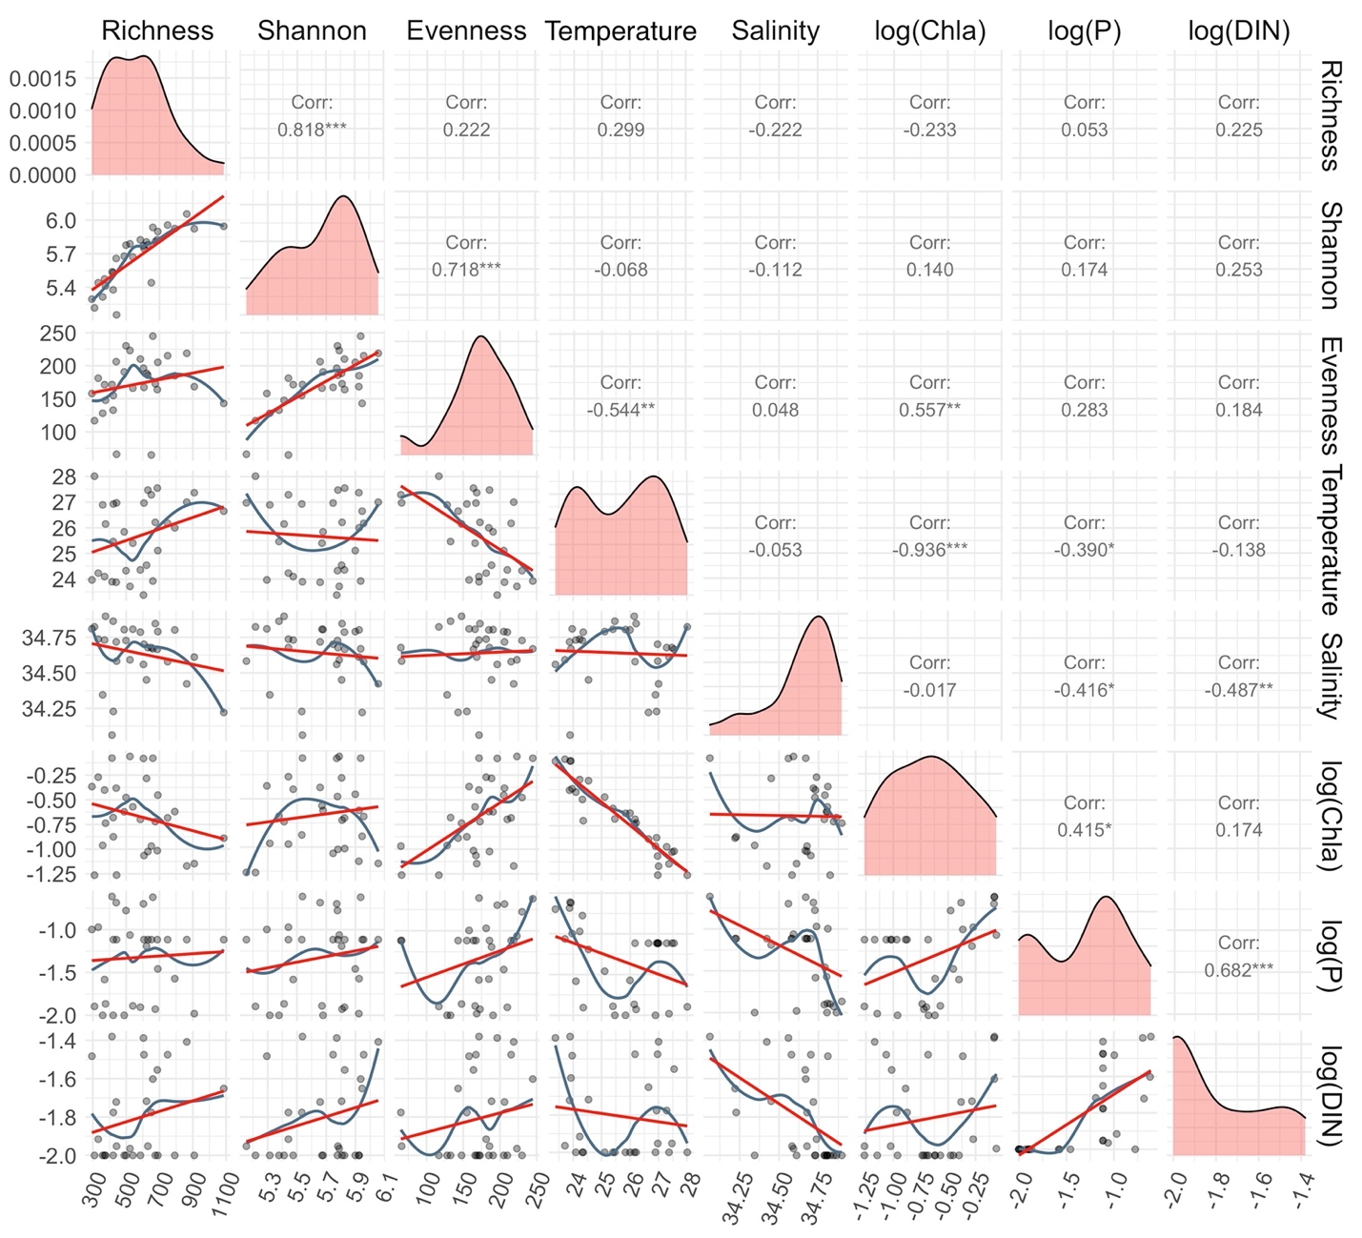

Figure S1. Correlation among diversity indexes and predictors in the surface layer. The lower triangle plots illustrate the scatter plots, smooth curve fit (blue), and linear fit (red). The diagonal plots illustrate the curve plot of the density of dots on the scatter plots. The upper triangle illustrates the Pearson correlation coefficient. P-value is marked in stars accordingly ( ".": p-value is < 0.10, "*": p-value is < 0.05, "**": p-value is < 0.01, , "***": p-value is < 0.001).

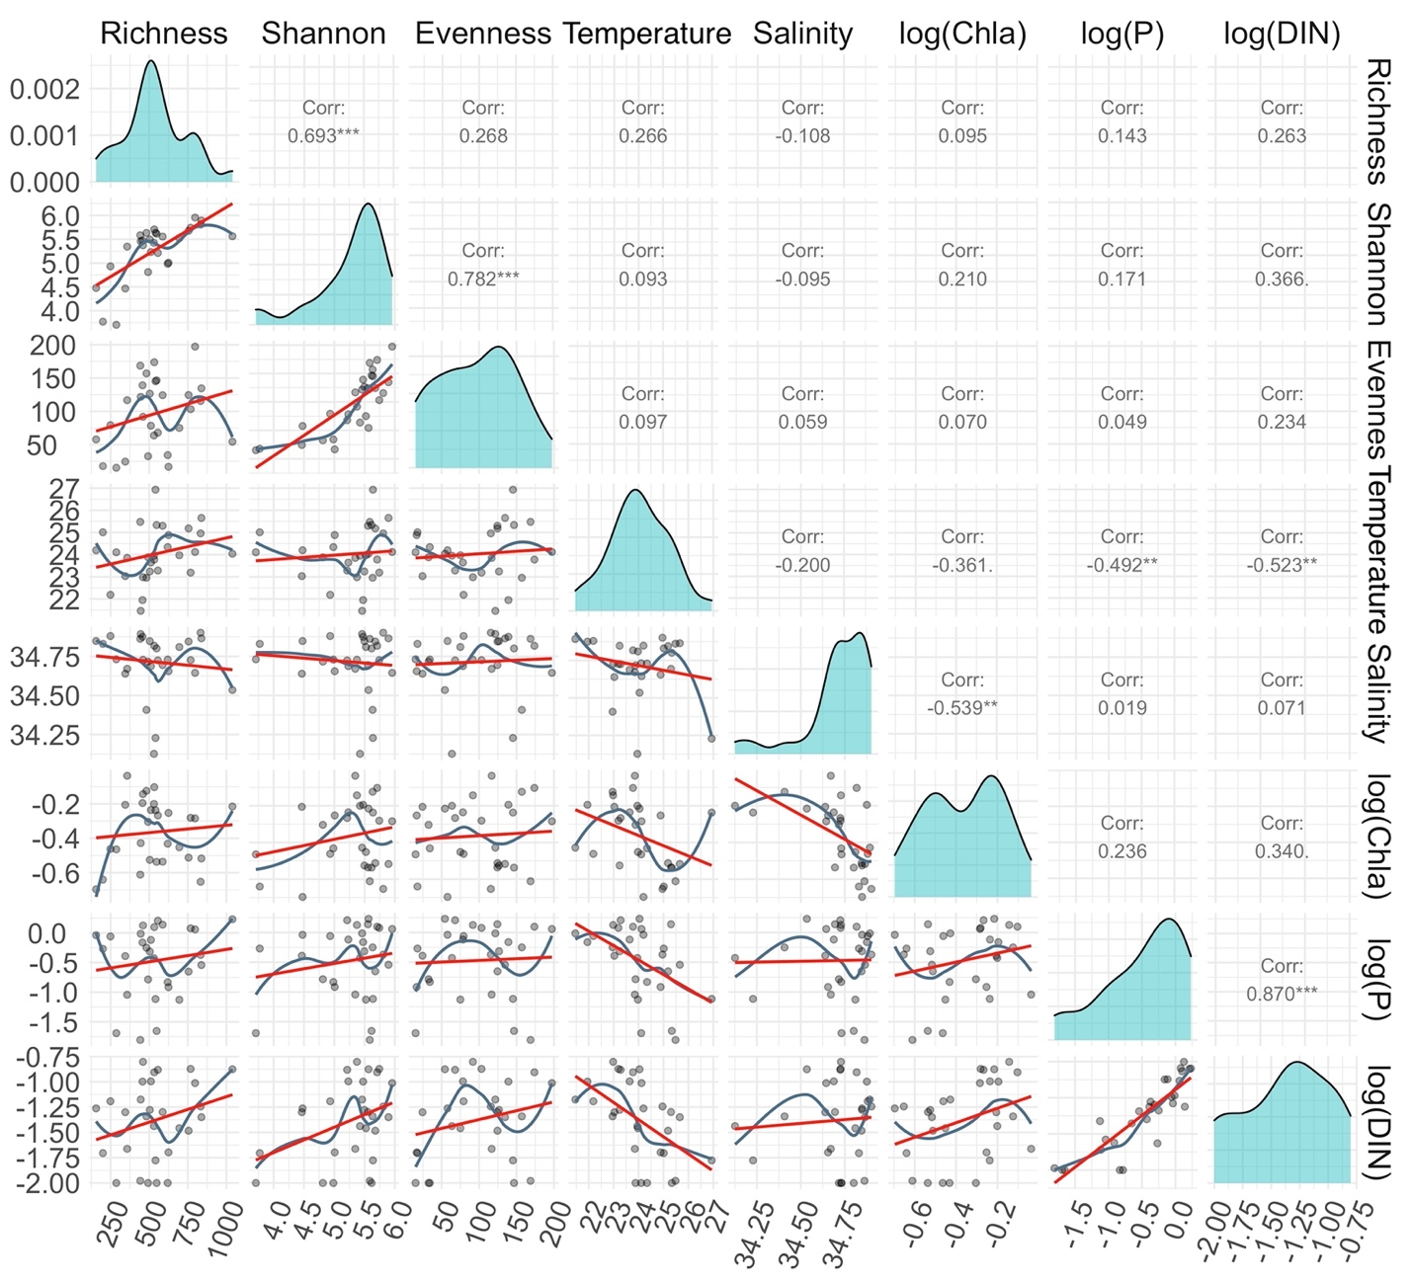Figure S2. Correlation among diversity indexes and predictors in the DCM layer. The lower triangle plots illustrate the scatter plots, smooth curve fit (blue), and linear fit (red). The diagonal plots illustrate the curve plot of the density of dots on the scatter plots. The upper triangle illustrates the Pearson correlation coefficient. P-value is marked in stars accordingly ( ".": p-value is < 0.10, "*": p-value is < 0.05, "**": p-value is < 0.01, , "***": p-value is < 0.001).

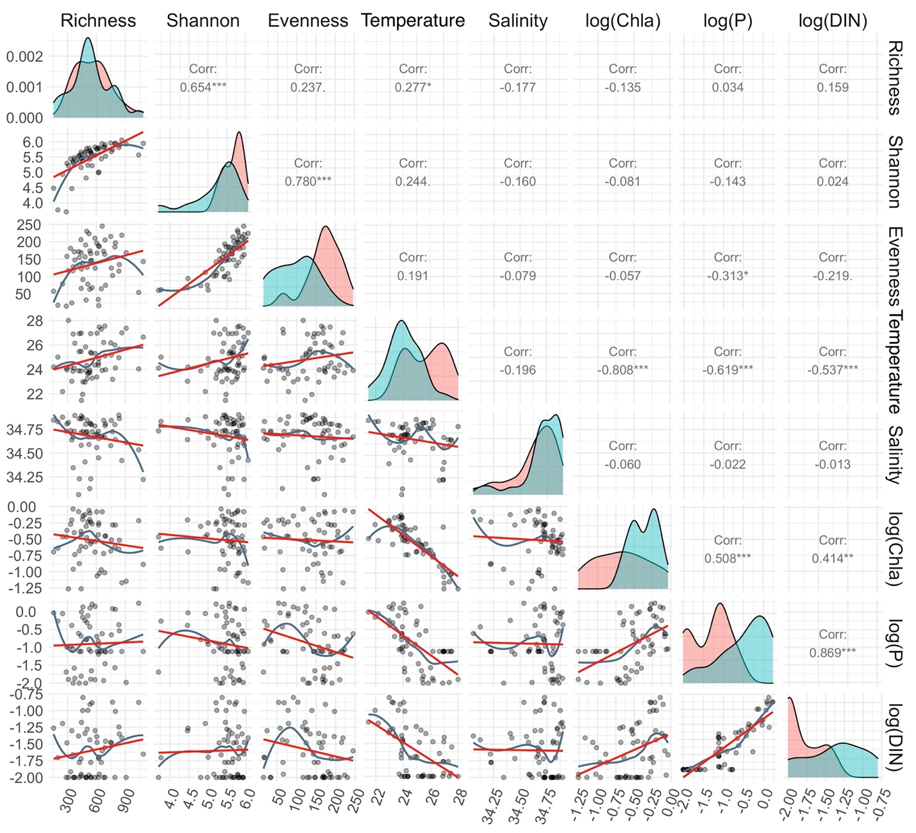Figure S3. Correlation among diversity indexes and predictors when combining both the surface and DCM layers. The lower triangle plots illustrate the scatter plots, smooth curve fit (blue), and linear fit (red). The diagonal plots illustrate the curve plot of the density of dots on the scatter plots for the surface (green shade) and the DCM layer (orange shade). The upper triangle illustrates the Pearson correlation coefficient. P-value is marked in stars accordingly ( ".": p-value is < 0.10, "*": p-value is < 0.05, "**": p-value is < 0.01, , "***": p-value is < 0.001).

Supplement II

In this supplement, we detail the methods used to extract and sequence DNA as well as analyze sequences

*DNA extraction and amplicon sequencing method*

Bacterial communities were determined with 16S rDNA using MiSeq paired-end sequencing (Illumina, CA, USA). PCR was performed in two steps to avoid barcode bias (Berry et al. 2011). The V5–V6 region (∼300 bp) of the 16S rDNA was amplified by using the forward primer FIA-787F (5'-[forward index adaptor]-ATTAGATACCCNGGTAG-3') and reverse primer RIA-1046R (5'-[reverse index adaptor]-CGACAGCCATGCANCACCT-3') (Cai et al. 2013).

16s rDNA PCR used the amplification mix containing: 1 U of *Taq* DNA polymerase (Promega), 1 × reaction buffer, 1.5 mM MgCl2, 0.2 mM dNTPs, 0.2 mM of primers, and 2 ng DNA. The PCR conditions were an initial denaturation at 94 °C for 3 min; 25 cycles of 94 °C for 30 s, 55 °C for 45 s, 72 °C for 1 min; and a final extension at 72 °C for 2 min. Three to eight PCR amplifications were pooled and purified using AMPure XP beads (Beckman Coulter Genomic, CA, USA) according to the manufacturer's instructions. The purified products were quantified using a Qubit fluorometer (Invitrogen, Carlsbad, CA, USA) with Qubit dsDNA BR Assay Kit (Life Technologies, USA).

A second PCR was performed using primers containing sample-specific barcodes and Illumina adaptors. The PCR mix included: 1 U of Taq DNA polymerase, one × reaction buffer, 1.5 mM MgCl2, 0.2 mM dNTPs, 0.2 mM of S5, and N7 primers (Nextera Index Kit), and 2 ng DNA purified from the first PCR product. The PCR conditions were an initial denaturation at 94 °C for 3 min; 6 cycles of 94 °C for 30 s, 55 °C for 45 s, 72 °C for 1 min; and a final extension at 72 °C for 2 min. Three sets of second PCR amplification for each sample were pooled, purified, and quantified using the same protocol as previously mentioned. Final products with unique barcodes were pooled in equal concentrations for the Illumina Miseq platform, producing two × 300 bp paired-end reads.

*ASVs processing:*

After receiving the raw sequence, we strictly followed the pipeline suggested in the DADA2 v 1.12 (Callahan et al. 2016) to process sequence data. Merged sequence reads were then calculated to provide an amplicon sequence variant (ASV) of bacteria using the function “*filterAndTrim”* and quality plots according to the DADA2 pipeline suggestions (code section 1). With raw sequence, we truncated the forward and reverse sequence length so that the average quality score started to fall lower than Q30. Specifically, for this study, sequences were truncated at position 270-bp for forward reads and 260-bp for reverse reads. After trimming the sequences to remain high quality, we remove primers. The error rate of each sample was calculated for amplicon resolution adjustments with the function “*learnErrors*” (code section 2). Fasta files were imported into derep-class objects by function “*derepFastq*” (code section 3). High-quality sequences were clustered with high resolution for samples with the function “*dada*” (code section 4). High-resolution clusters were then merged by combining paired-end reads with the function *"mergePairs"* at a minimum of 12-bp overlap required in the DADA2 pipeline (code section 5). ASVs table were then assembled with function *"makeSequenceTable"* (code section 6). The expected length range of merged sequences was selected for further denoising process. After the ASVs table was assembled, chimeras were detected and removed from the ASVs table using the function *"removeBimeraDenovo"* (code section 6). After ASVs were assigned taxonomy, only kingdom “bacteria” was selected following the design of the primers (Cai et al. 2013).

The conditionally mandatory parameters for amplicons and the sequence data without artificial sequences were deposited with links to BioProject accession number PRJNA798158 in the NCBI BioProject database (<https://www.ncbi.nlm.nih.gov/bioproject/>).

*DADA2 pipeline R code:*

#################################################################

# (1) - Trimming raw sequence to meeting DADA2 pipeline requests #

#################################################################

out <- filterAndTrim(fnFs, filtFs, fnRs, filtRs, # raw sequence data

truncLen=c(270,260), # truncate quality score lowwer than Q30

trimLeft=c(17,19), # Remove of primer

maxN=0, maxEE=c(2,2), truncQ=2, rm.phix=TRUE,compress=TRUE, multithread=TRUE) # Remove of faluty amplicons

#################################################################

# (2) - Error rates learning #

#################################################################

errF <- learnErrors(filtFs, multithread=TRUE)

errR <- learnErrors(filtRs, multithread=TRUE)

#################################################################

# (3) - Corresponding fasta files into derep-class objects and naming #

#################################################################

derepFs <- derepFastq(filtFs, verbose=TRUE)

names(derepFs) <- sample.names

derepRs <- derepFastq(filtRs, verbose=TRUE)

names(derepRs) <- sample.names

#################################################################

# (4) - High resolution sample inference from amplicon data #

#################################################################

dadaFs <- dada(derepFs, err=errF, multithread=TRUE)

dadaRs <- dada(derepRs, err=errR, multithread=TRUE)

#################################################################

# (5) - Merge denoised forward and reverse reads #

#################################################################

mergers <- mergePairs(dadaFs, derepFs, dadaRs, derepRs, verbose=TRUE)

#################################################################

# (6) - Construct a sample-by-sequence observation matrix #

#################################################################

seqtab <- makeSequenceTable(mergers)

seqtab2 <- seqtab[,nchar(colnames(seqtab)) %in% seq(253,258)] # ideal length range of merged sequences

seqtab.nochim <- removeBimeraDenovo(seqtab2, method="consensus", multithread=TRUE, verbose=TRUE) # Remove bimeras from collections of unique sequences.

ASVs <- seqtab.nochim

Supplement III

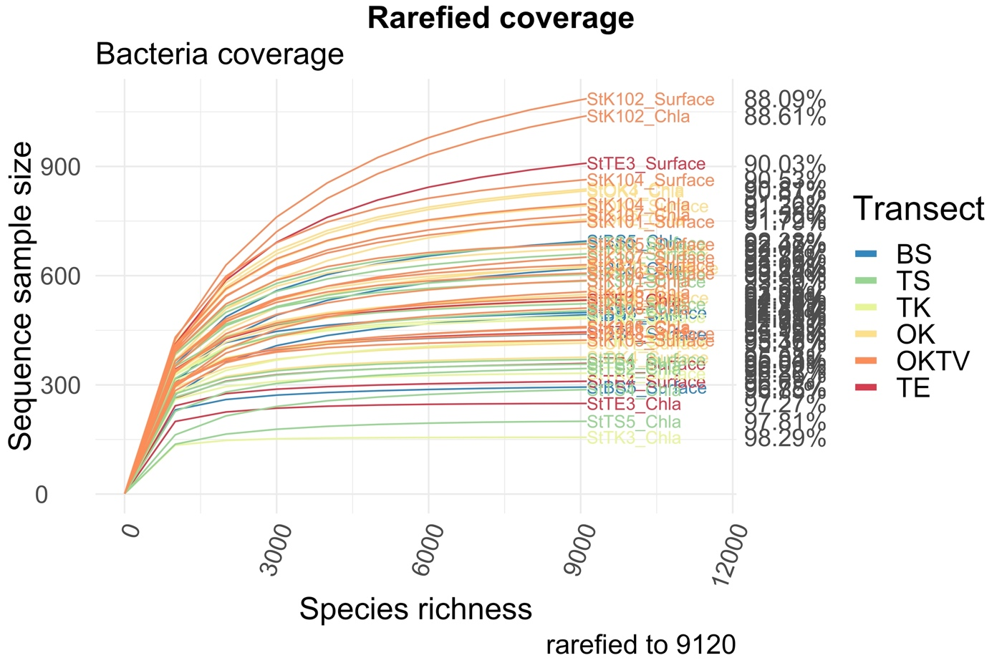In this supplement, we visualize the rarefication of bacterioplankton diversity.

Figure S4. Rarefaction curve of each sampling. The color of the line represents the transect from which bacterial samples were taken.

Supplement IV

In this supplement, we visualize the traditional RDA ordination of bacterioplankton.

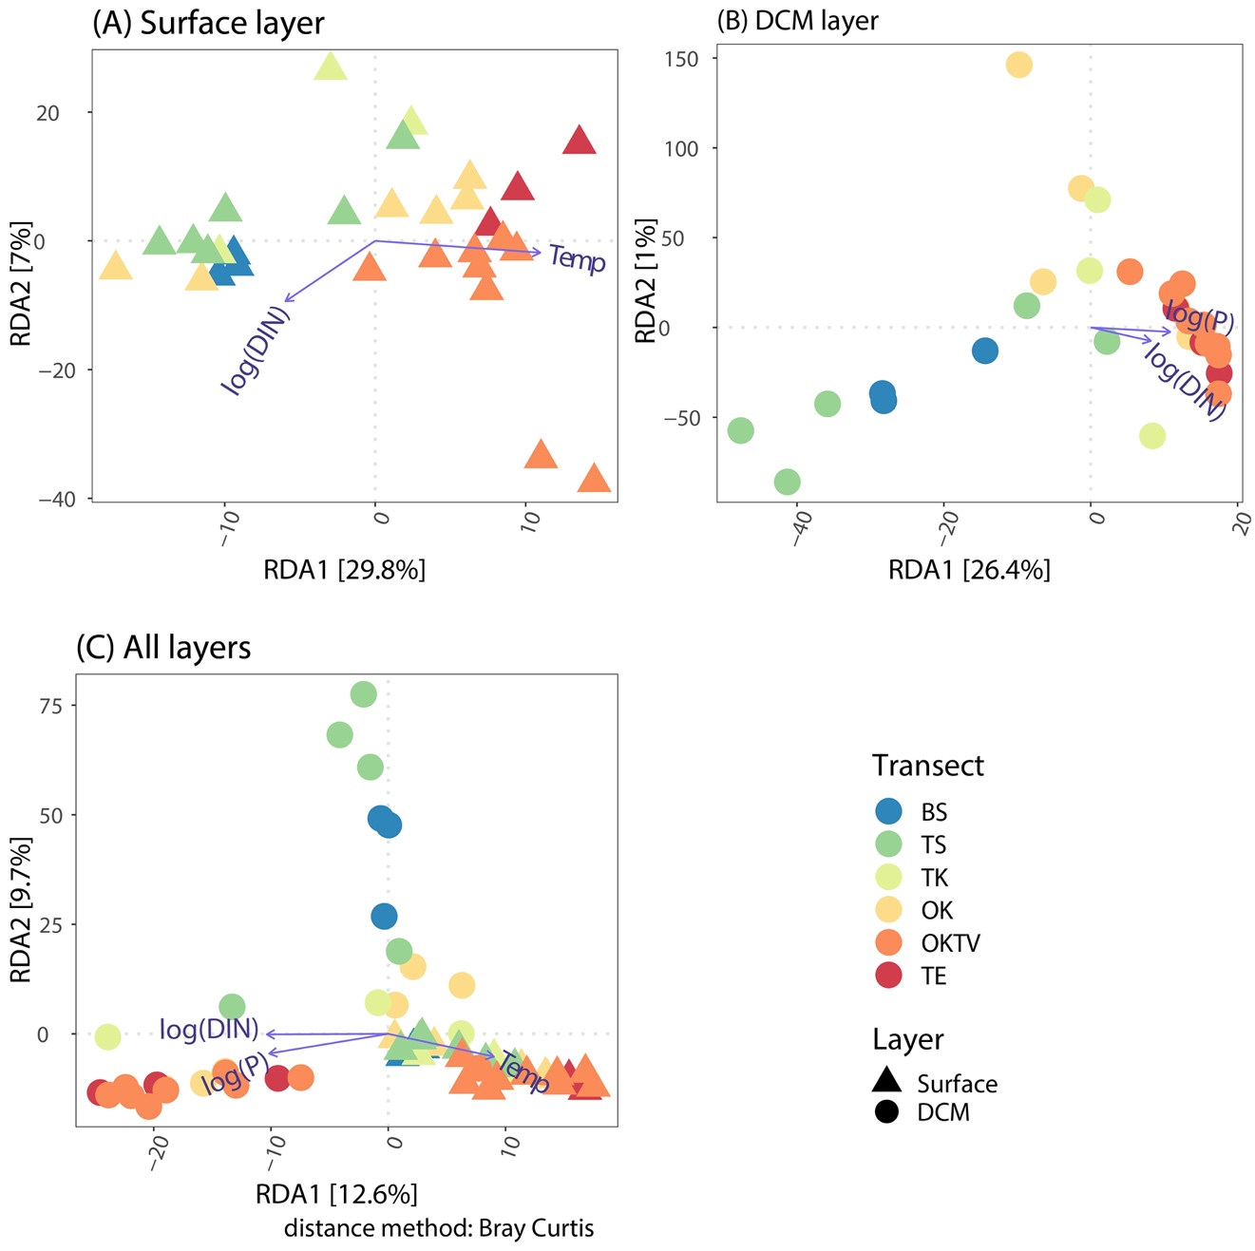

Figure S5. Ordination plots show the environmental factors significantly contributing to the changes of bacterial ASV composite along the Kuroshio in the surface (A), deep chlorophyll-a maximum layer (B), and the combination of two layers (C). The color and shape of the dots represent the transect and the layer from which bacterial samples were taken.

Supplement V

In this supplement, we visualize the results of generalized linear models (GLMs) or generalized linear mixed effect model (GLMMs) when the surface and the deep chlorophyll-a maximum layers were combined, examining how bacterial diversities varied with temperature, salinity, the concentration of chlorophyll-a, dissolved inorganic nitrogen and phosphate. Inside the panels of each figure, we reported the R2 and *p* of GLMs or marginal R2, conditional R2, and *p* of GLMM.

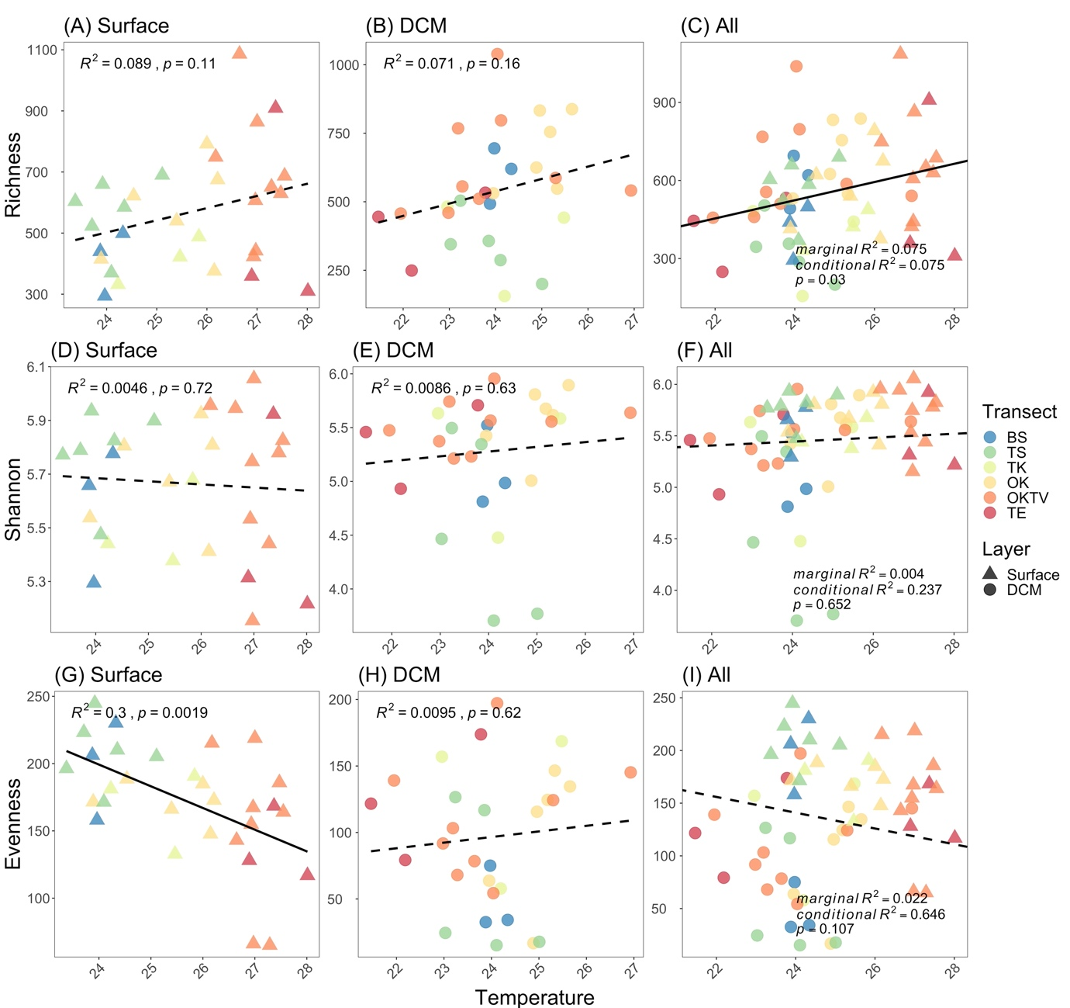Figure S6. Scatter plots showing the relationships between temperature versus bacterial richness (A to C), Shannon diversity (D to F), and evenness (G to I) in the surface (A, D, and G), deep chlorophyll-a maximum layer (B, E, and H) and the combination of two layers (C, F, and I). The color and shape of the dots represent the transect and the layer from which bacterial samples were taken. Solid lines represent significant regressions from the generalized linear model or generalized linear mixed effect model if two layers are combined, while dashed lines represent non-significant regressions.

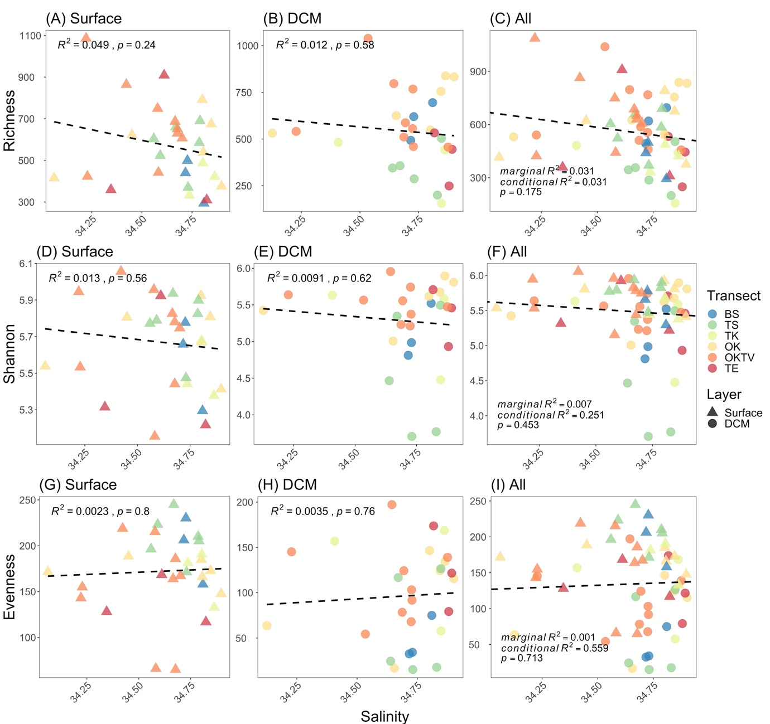Figure S7. Scatter plots showing the relationships between salinity versus bacterial richness (A to C), Shannon diversity (D to F), and evenness (G to I) in the surface (A, D, and G), deep chlorophyll-a maximum layer (B, E, and H) and the combination of two layers (C, F, and I). The color and shape of the dots represent the transect and the layer from which bacterial samples were taken. Dashed lines represent non-significant regressions.

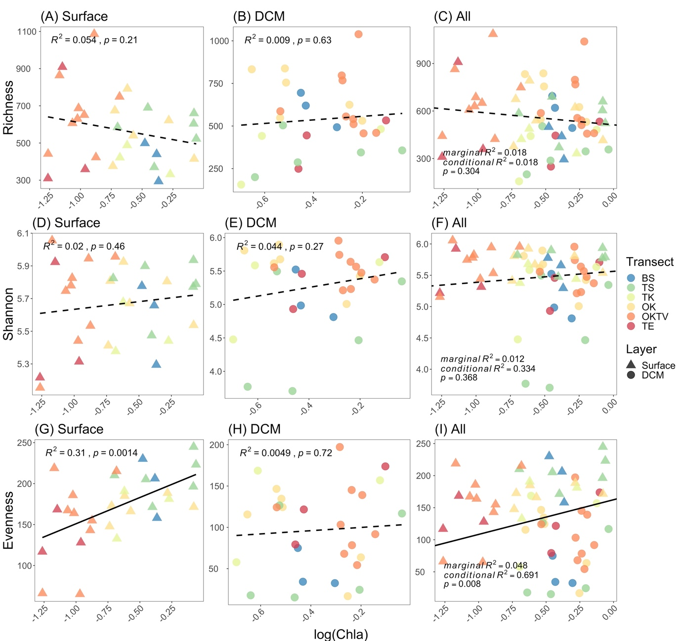Figure S8. Scatter plots showing the relationships between log-scaled chlorophyll-a concentration versus bacterial richness (A to C), Shannon diversity (D to F), and evenness (G to I) in the surface (A, D, and G), deep chlorophyll-a maximum layer (B, E, and H) and the combination of two layers (C, F, and I). The color and shape of the dots represent the transect and the layer from which bacterial samples were taken. Solid lines represent significant regressions from the generalized linear model or generalized linear mixed effect model if two layers are combined, while dashed lines represent non-significant regressions.

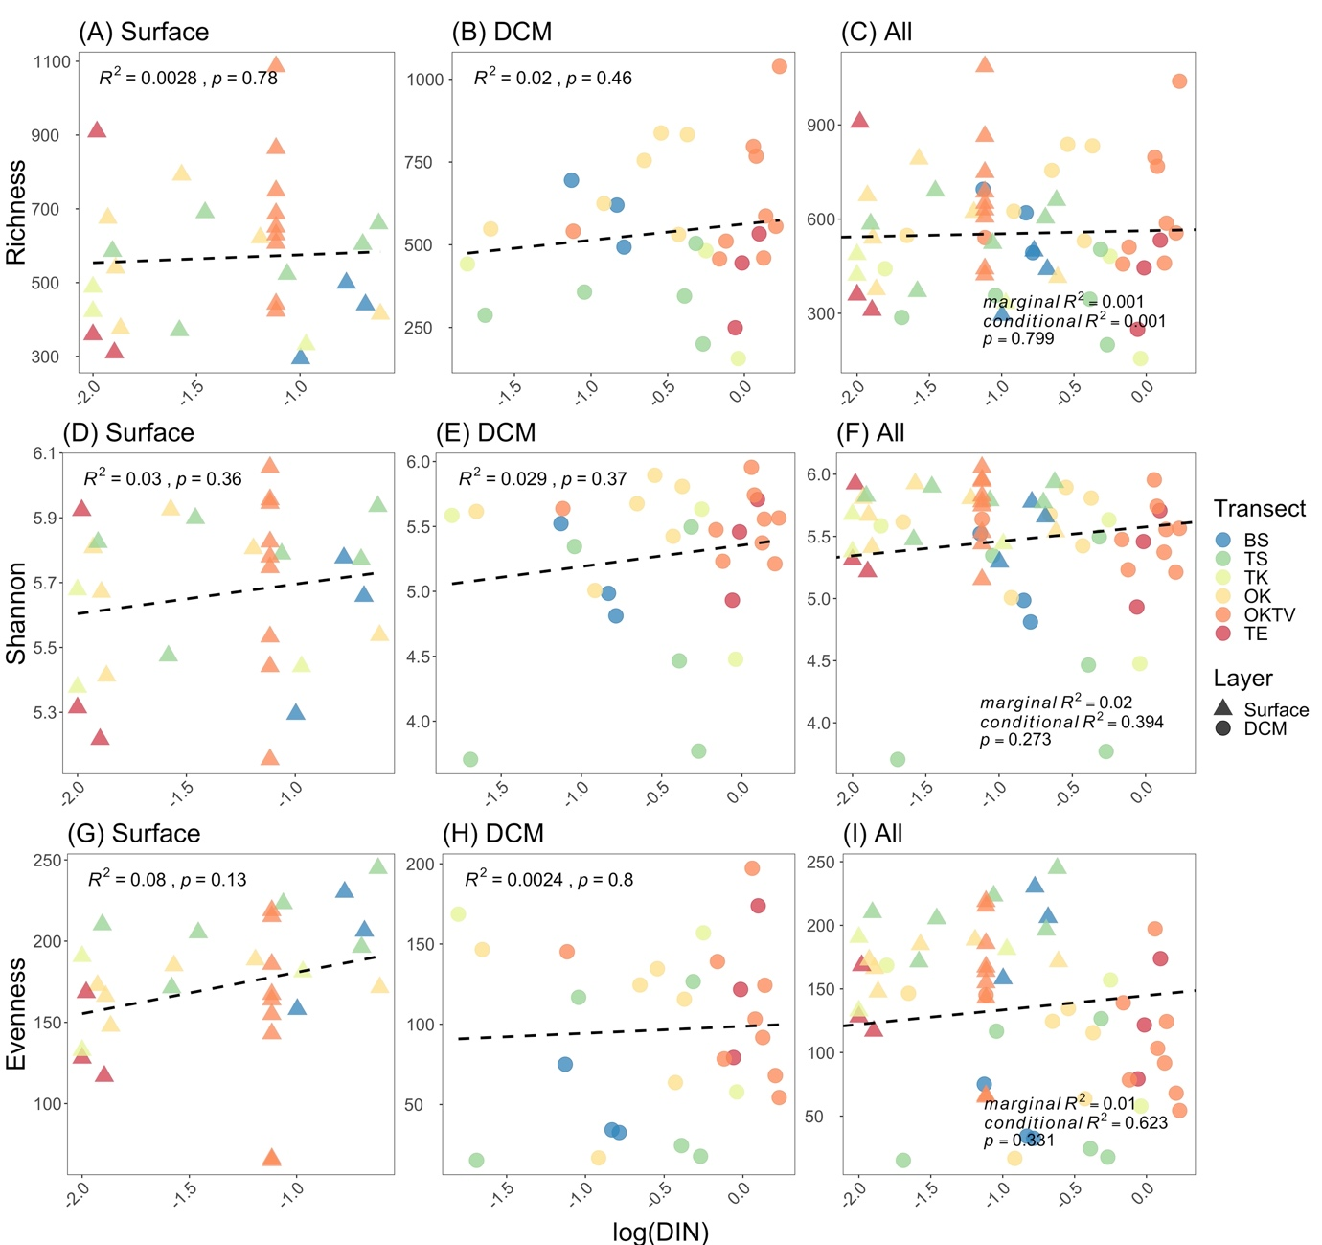Figure S9. Scatter plots showing the relationships between log-scaled dissolved inorganic nitrogen concentration (*DIN*) versus bacterial richness (A to C), Shannon diversity (D to F), and evenness (G to I) in the surface (A, D, and G), deep chlorophyll-a maximum layer (B, E, and H) and the combination of two layers (C, F, and I). The color and shape of the dots represent the transect and the layer from which bacterial samples were taken. Dashed lines represent non-significant regressions.

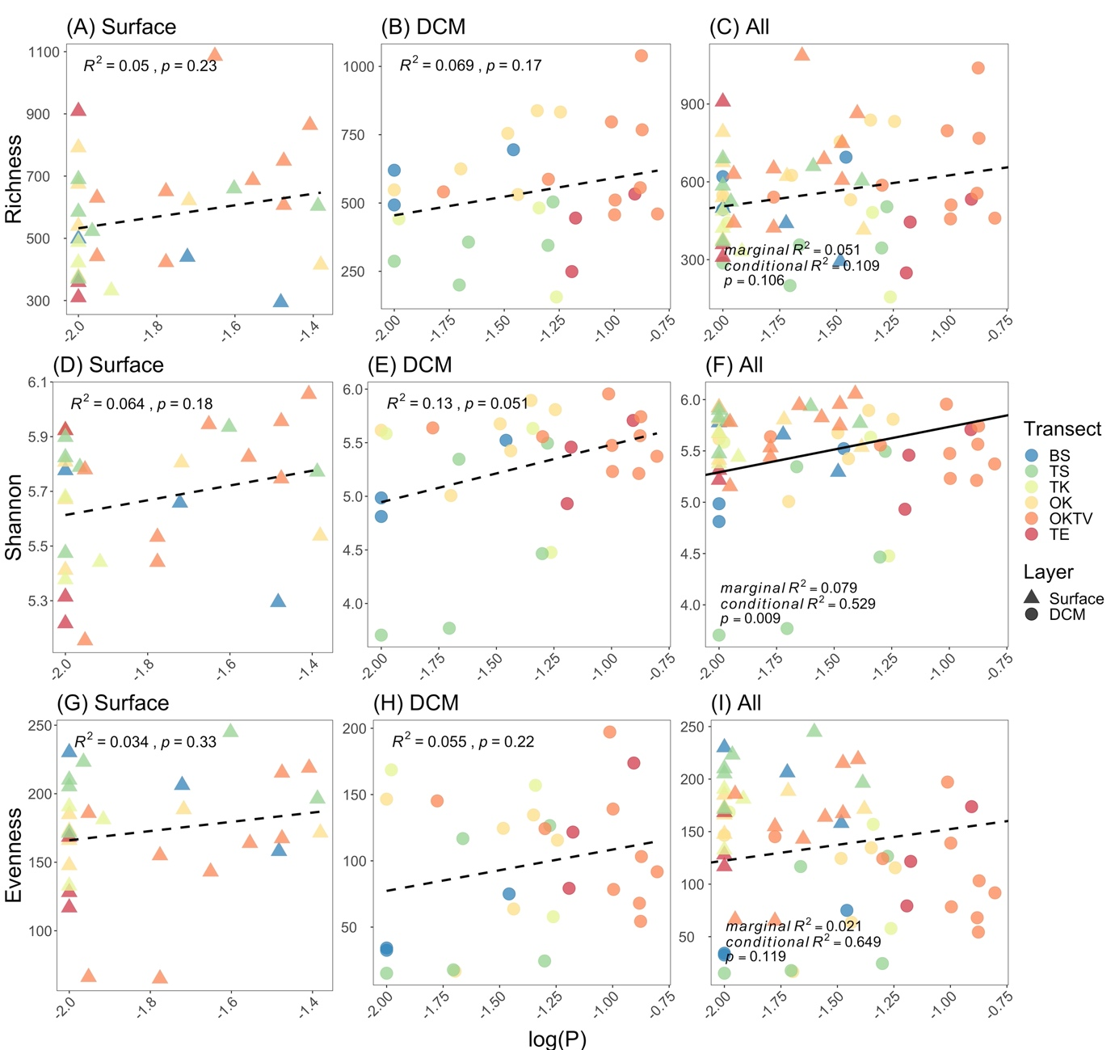Figure S10. Scatter plots showing the relationships between log-scaled phosphate concentration (*P*) verses bacterial richness (A to C), Shannon diversity (D to F), and evenness (G to I) in the surface (A, D, and G), deep chlorophyll-a maximum layer (B, E, and H) and the combination of two layers (C, F, and I). The color and shape of the dots represent the transect and the layer from which bacterial samples were taken. The solid line represents significant regression from the generalized linear mixed effect model if two layers are combined, while dashed lines represent non-significant regressions.

Supplement VI

In this supplement, we detail the steps of backward stepwise selection analyses. Specifically, a generalized linear model (GLM) was a performed on the surface and DCM layer, while generalized linear mixed-effect model (GLMM) with layer as the random effect was performed when two layers were combined. In each step, the independent variable with the non-significant highest p-value is removed and labeled in italic font. The selection criteria based on model R2 and AIC produces consistent results.

Table S2. Backward stepwise selection analyses.

|  |  |  |  |  |  |  |  |  |  |  |  |  |
| --- | --- | --- | --- | --- | --- | --- | --- | --- | --- | --- | --- | --- |
| Dependent variable | Independent variable | Model R2 | Model AIC | p-value | Independent variable | Model R2 | Model AIC | p-value | Independent variable | Model R2 | Model AIC | p-value |
| Richness | Surface | | | | DCM | | | | All | | | |
| Step 1 | | | | Step 1 | | | | Step 1 | | | |
| Temperature | 0.151 | 407.200 | 0.316 | Temperature | 0.279 | 392.187 | 0.021 | Temperature | 0.226 | 729.497 | 0.007 |
| Salinity | 0.151 | 407.200 | 0.698 | *Salinity* | *0.279* | *392.187* | *0.896* | *Salinity* | *0.226* | *729.497* | *0.891* |
| log(Chla) | 0.151 | 407.200 | 0.637 | log(Chla) | 0.279 | 392.187 | 0.625 | log(Chla) | 0.226 | 729.497 | 0.209 |
| *log(DIN)* | *0.151* | *407.200* | *0.896* | log(DIN) | 0.279 | 392.187 | 0.550 | log(DIN) | 0.226 | 729.497 | 0.544 |
| log(P) | 0.151 | 407.200 | 0.380 | log(P) | 0.279 | 392.187 | 0.077 | log(P) | 0.226 | 729.497 | 0.026 |
| Step 2 | | | | Step 2 | | | | Step 2 | | | |
| Temperature | 0.155 | 405.222 | 0.296 | Temperature | 0.287 | 390.209 | 0.010 | Temperature | 0.229 | 739.098 | 0.002 |
| *Salinity* | *0.155* | *405.222* | *0.706* | *log(Chla)* | *0.287* | *390.209* | *0.569* | log(Chla) | 0.229 | 739.098 | 0.154 |
| log(Chla) | 0.155 | 405.222 | 0.636 | log(DIN) | 0.287 | 390.209 | 0.498 | *log(DIN)* | *0.229* | *739.098* | *0.547* |
| log(P) | 0.155 | 405.222 | 0.312 | log(P) | 0.287 | 390.209 | 0.053 | log(P) | 0.229 | 739.098 | 0.024 |
| Step 3 | | | | Step 3 | | | | Step 3 | | | |
| Temperature | 0.156 | 403.396 | 0.250 | Temperature | 0.286 | 388.610 | 0.011 | Temperature | 0.228 | 747.907 | 0.001 |
| *log(Chla)* | *0.156* | *403.396* | *0.587* | *log(DIN)* | *0.286* | *388.610* | *0.432* | *log(Chla)* | *0.228* | *747.907* | *0.164* |
| log(P) | 0.156 | 403.396 | 0.167 | log(P) | 0.286 | 388.610 | 0.033 | log(P) | 0.228 | 747.907 | 0.003 |
| Step 4 | | | | Step 4 | | | | Step 4 | | | |
| Temperature | 0.152 | 401.744 | 0.069 | Temperature | 0.277 | 387.339 | 0.008 | Temperature | 0.204 | 759.290 | 0.001 |
| *log(P)* | *0.152* | *401.744* | *0.139* | log(P) | 0.277 | 387.339 | 0.008 | log(P) | 0.204 | 759.290 | 0.003 |
| Step 5 | | | |  | | | |  | | | |
| *Temperature* | *0.087* | *402.217* | *0.108* |
| Step 6 | | | |
| ~1 |  |  |  |
| Shannon | Surface | | | | DCM | | | | All | | | |
| Step 1 | | | | Step 1 | | | | Step 1 | | | |
| Temperature | 0.086 | 10.927 | 0.403 | Temperature | 0.294 | 50.703 | 0.095 | Temperature | 0.536 | 85.025 | 0.022 |
| Salinity | 0.086 | 10.927 | 0.872 | *Salinity* | *0.294* | *50.703* | *0.982* | *Salinity* | *0.536* | *85.025* | *0.541* |
| log(Chla) | 0.086 | 10.927 | 0.329 | log(Chla) | 0.294 | 50.703 | 0.578 | log(Chla) | 0.536 | 85.025 | 0.023 |
| *log(DIN)* | *0.086* | *10.927* | *0.906* | log(DIN) | 0.294 | 50.703 | 0.178 | log(DIN) | 0.536 | 85.025 | 0.220 |
| log(P) | 0.086 | 10.927 | 0.354 | log(P) | 0.294 | 50.703 | 0.018 | log(P) | 0.536 | 85.025 | 0.003 |
| Step 2 | | | | Step 2 | | | | Step 2 | | | |
| Temperature | 0.089 | 8.945 | 0.383 | Temperature | 0.303 | 48.704 | 0.058 | Temperature | 0.143 | 82.845 | 0.023 |
| *Salinity* | *0.089* | *8.945* | *0.848* | *log(Chla)* | *0.303* | *48.704* | *0.439* | log(Chla) | 0.143 | 82.845 | 0.025 |
| log(Chla) | 0.089 | 8.945 | 0.322 | log(DIN) | 0.303 | 48.704 | 0.149 | *log(DIN)* | *0.143* | *82.845* | *0.177* |
| log(P) | 0.089 | 8.945 | 0.279 | log(P) | 0.303 | 48.704 | 0.012 | log(P) | 0.143 | 82.845 | 0.003 |
| Step 3 | | | | Step 3 | | | | Step 3 | | | |
| *Temperature* | *0.091* | *6.990* | *0.385* | Temperature | 0.295 | 47.442 | 0.073 | Temperature | 0.128 | 81.001 | 0.013 |
| log(Chla) | 0.091 | 6.990 | 0.321 | *log(DIN)* | *0.295* | *47.442* | *0.113* | log(Chla) | 0.128 | 81.001 | 0.031 |
| log(P) | 0.091 | 6.990 | 0.248 | log(P) | 0.295 | 47.442 | 0.006 | log(P) | 0.128 | 81.001 | 0.003 |
| Step 4 | | | | Step 4 | | | |  | | | |
| *log(Chla)* | *0.069* | *5.877* | *0.602* | *Temperature* | *0.232* | *48.418* | *0.061* |
| log(P) | 0.069 | 5.877 | 0.221 | log(P) | 0.232 | 48.418 | 0.008 |
| Step 5 | | | | Step 5 | | | |
| *log(P)* | *0.062* | *4.184* | *0.177* | *log(P)* | *0.130* | *50.411* | *0.051* |
| Step 6 | | | | Step 6 | | | |
| ~1 |  |  |  | ~1 |  |  |  |
| Evenness | Surface | | | | DCM | | | | All | | | |
| Step 1 | | | | Step 1 | | | | Step 1 | | | |
| Temperature | 0.294 | 310.635 | 0.768 | Temperature | 0.183 | 317.446 | 0.203 | Temperature | 0.735 | 586.348 | 0.234 |
| Salinity | 0.294 | 310.635 | 0.535 | Salinity | 0.183 | 317.446 | 0.622 | Salinity | 0.735 | 586.348 | 0.179 |
| log(Chla) | 0.294 | 310.635 | 0.425 | *log(Chla)* | *0.183* | *317.446* | *0.715* | log(Chla) | 0.735 | 586.348 | 0.011 |
| *log(DIN)* | *0.294* | *310.635* | *0.949* | log(DIN) | 0.183 | 317.446 | 0.195 | *log(DIN)* | *0.735* | *586.348* | *0.469* |
| log(P) | 0.294 | 310.635 | 0.551 | log(P) | 0.183 | 317.446 | 0.059 | log(P) | 0.735 | 586.348 | 0.112 |
| Step 2 | | | | Step 2 | | | | Step 2 | | | |
| *Temperature* | *0.302* | *308.640* | *0.756* | Temperature | 0.185 | 315.618 | 0.202 | *Temperature* | *0.074* | *592.657* | *0.170* |
| Salinity | 0.302 | 308.640 | 0.527 | *Salinity* | *0.185* | *315.618* | *0.734* | Salinity | 0.074 | 592.657 | 0.137 |
| log(Chla) | 0.302 | 308.640 | 0.413 | log(DIN) | 0.185 | 315.618 | 0.133 | log(Chla) | 0.074 | 592.657 | 0.010 |
| log(P) | 0.302 | 308.640 | 0.423 | log(P) | 0.185 | 315.618 | 0.029 | log(P) | 0.074 | 592.657 | 0.107 |
| Step 3 | | | | Step 3 | | | | Step 3 | | | |
| *Salinity* | *0.308* | *306.758* | *0.475* | *Temperature* | *0.187* | *313.761* | *0.208* | *Salinity* | *0.066* | *598.508* | *0.318* |
| log(Chla) | 0.308 | 306.758 | 0.003 | log(DIN) | 0.187 | 313.761 | 0.116 | log(Chla) | 0.066 | 598.508 | 0.015 |
| log(P) | 0.308 | 306.758 | 0.409 | log(P) | 0.187 | 313.761 | 0.024 | log(P) | 0.066 | 598.508 | 0.229 |
| Step 4 | | | | Step 4 | | | | Step 4 | | | |
| log(Chla) | 0.303 | 305.358 | 0.002 | *log(DIN)* | *0.143* | *313.638* | *0.096* | log(Chla) | 0.059 | 606.193 | 0.020 |
| *log(P)* | *0.303* | *305.358* | *0.581* | log(P) | 0.143 | 313.638 | 0.042 | *log(P)* | *0.059* | *606.193* | *0.275* |
| Step 5 | | | | Step 5 | | | | Step 5 | | | |
| log(Chla) | 0.303 | 303.703 | 0.001 | *log(P)* | *0.053* | *314.792* | *0.223* | log(Chla) | 0.048 | 613.118 | 0.010 |
|  | | | | Step 6 | | | |  | | | |
| ~1 |  |  |  |

Supplement VII

In this supplement, we visualize the results of permutated generalized linear models (GLMs) or permutated generalized linear mixed effect model (GLMMs) when the surface and the deep chlorophyll-a maximum layer were combined, examining how the relative abundance of selected bacterial genera varied with temperature, salinity, the log-scaled concentration of chlorophyll-a, log-scaled dissolved inorganic nitrogen, and log-scaled phosphate. The selected bacterial genera show significantly different relative abundance among the six transects. Inside the panels of each figure, we reported the R2 and permutated p-value of GLMs or conditional R2, marginal R2, and permutated p-value of GLMM.

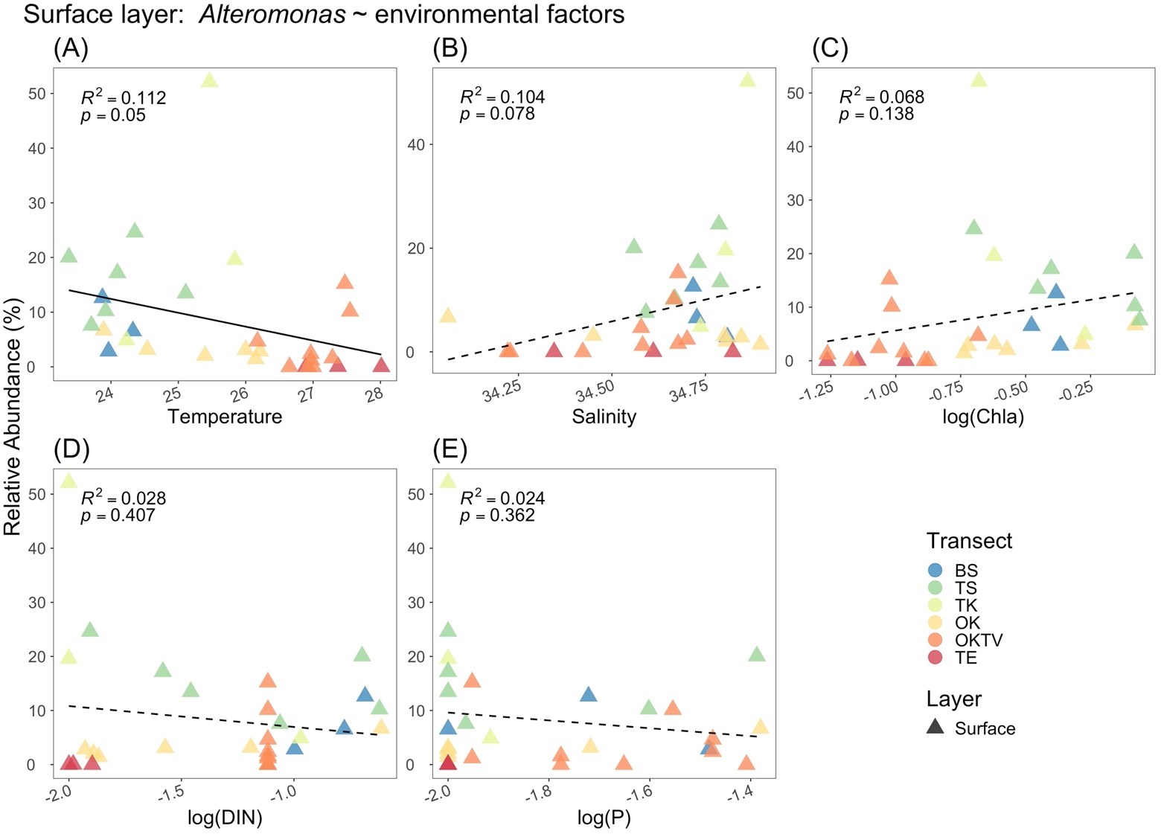

Figure S11. Scatter plots show the relationships between the relative abundance of genus *Alteromonas* versus temperature, salinity, the log-scaled concentration of chlorophyll-a, log-scaled dissolved inorganic nitrogen, and log-scaled phosphate in the surface layer. The color and shape of the dots represent the transect and the layer from which bacterial samples were taken. Solid lines represent significant regressions from the permutated generalized linear model, while dashed lines represent non-significant permutated regressions.

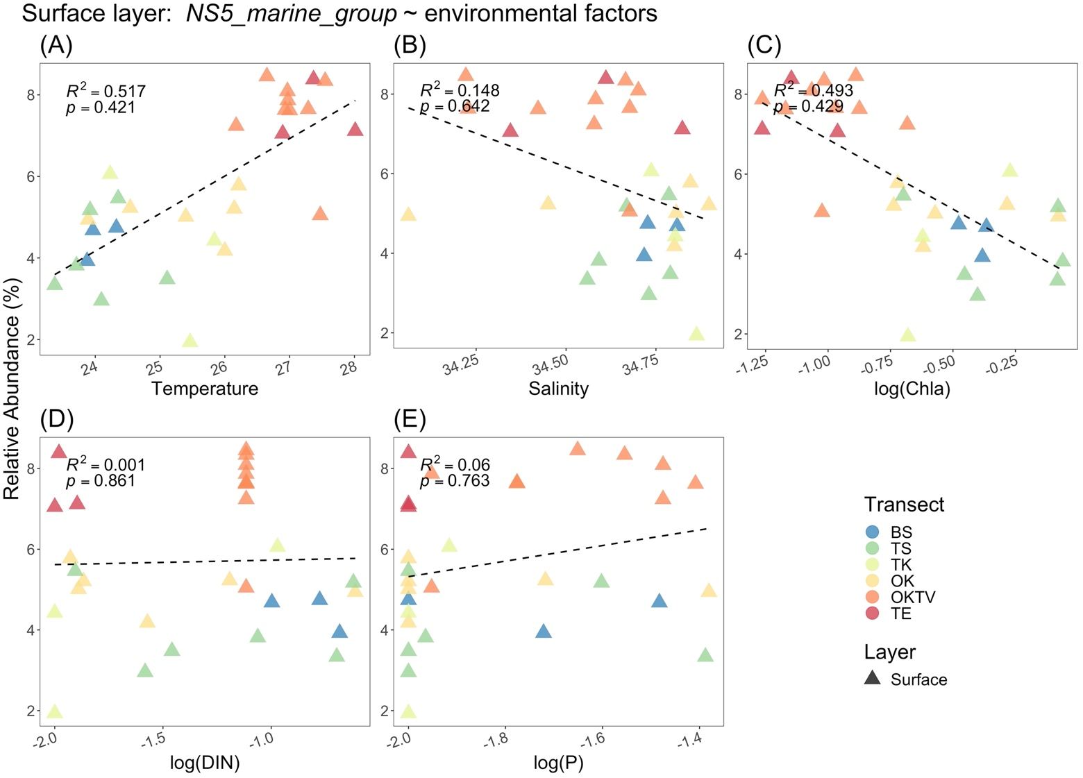

Figure S12. Scatter plots show the relationships between the relative abundance of genus *NS5_marine_group* versus temperature, salinity, the log-scaled concentration of chlorophyll-a, log-scaled dissolved inorganic nitrogen, and log-scaled phosphate in the surface layer. The color and shape of the dots represent the transect and the layer from which bacterial samples were taken. Solid lines represent significant regressions from the permutated generalized linear model, while dashed lines represent non-significant permutated regressions.

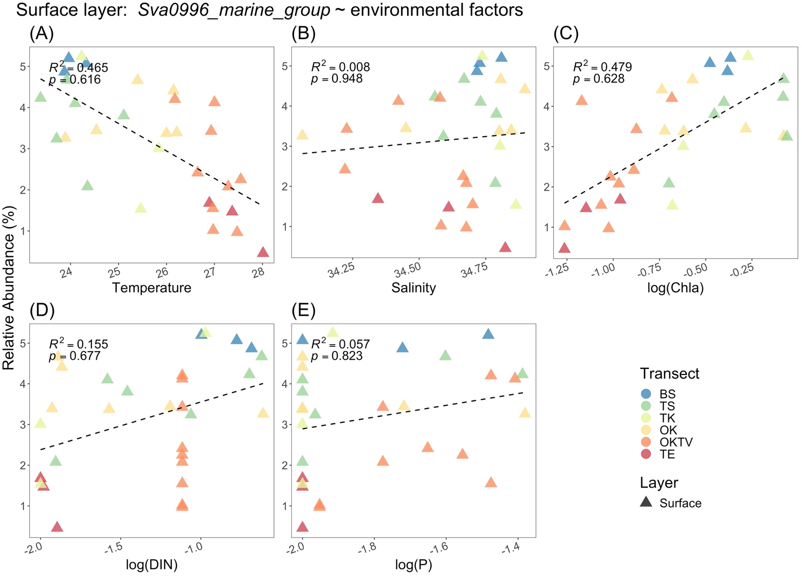

Figure S13. Scatter plots show the relationships between the relative abundance of genus *Sva0996_marine_group* versus temperature, salinity, the log-scaled concentration of chlorophyll-a, log-scaled dissolved inorganic nitrogen, and log-scaled phosphate in the surface layer. The color and shape of the dots represent the transect and the layer from which bacterial samples were taken. Solid lines represent significant regressions from the permutated generalized linear model, while dashed lines represent non-significant permutated regressions.

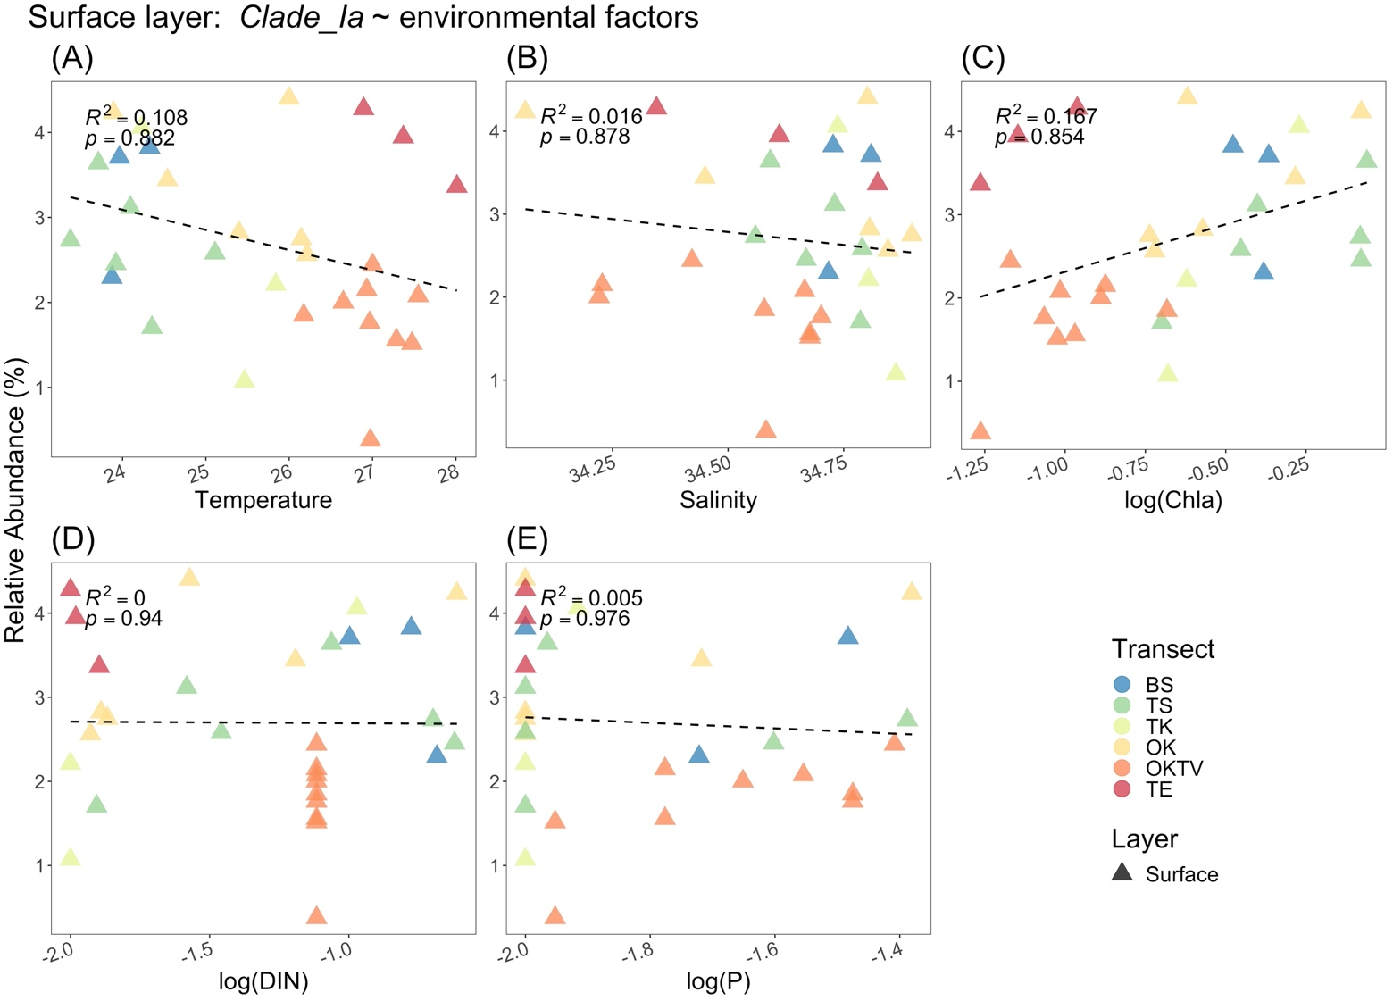

Figure S14. Scatter plots show the relationships between the relative abundance of genus *Clade_la* versus temperature, salinity, the log-scaled concentration of chlorophyll-a, log-scaled dissolved inorganic nitrogen, and log-scaled phosphate in the surface layer. The color and shape of the dots represent the transect and the layer from which bacterial samples were taken. Solid lines represent significant regressions from the permutated generalized linear model, while dashed lines represent non-significant permutated regressions.

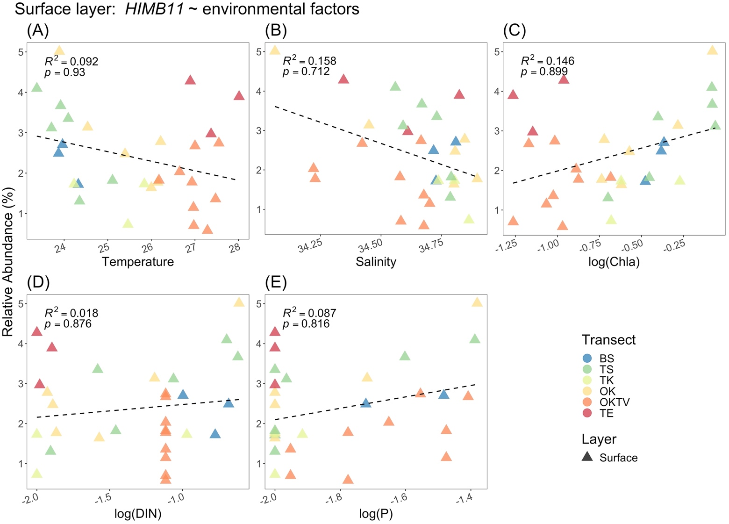

Figure S15. Scatter plots show the relationships between the relative abundance of genus *HIMB1* versus temperature, salinity, the log-scaled concentration of chlorophyll-a, log-scaled dissolved inorganic nitrogen, and log-scaled phosphate in the surface layer. The color and shape of the dots represent the transect and the layer from which bacterial samples were taken. Solid lines represent significant regressions from the permutated generalized linear model, while dashed lines represent non-significant permutated regressions.

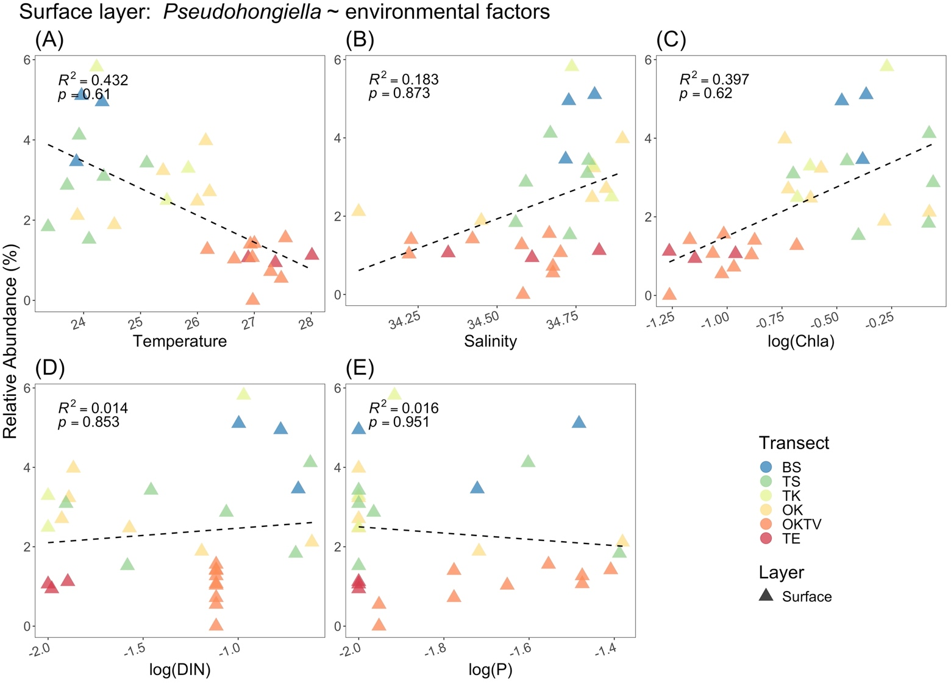

Figure S16. Scatter plots show the relationships between the relative abundance of genus *Pseudohongiella* versus temperature, salinity, the log-scaled concentration of chlorophyll-a, log-scaled dissolved inorganic nitrogen, and log-scaled phosphate in the surface layer. The color and shape of the dots represent the transect and the layer from which bacterial samples were taken. Solid lines represent significant regressions from the permutated generalized linear model, while dashed lines represent non-significant permutated regressions.

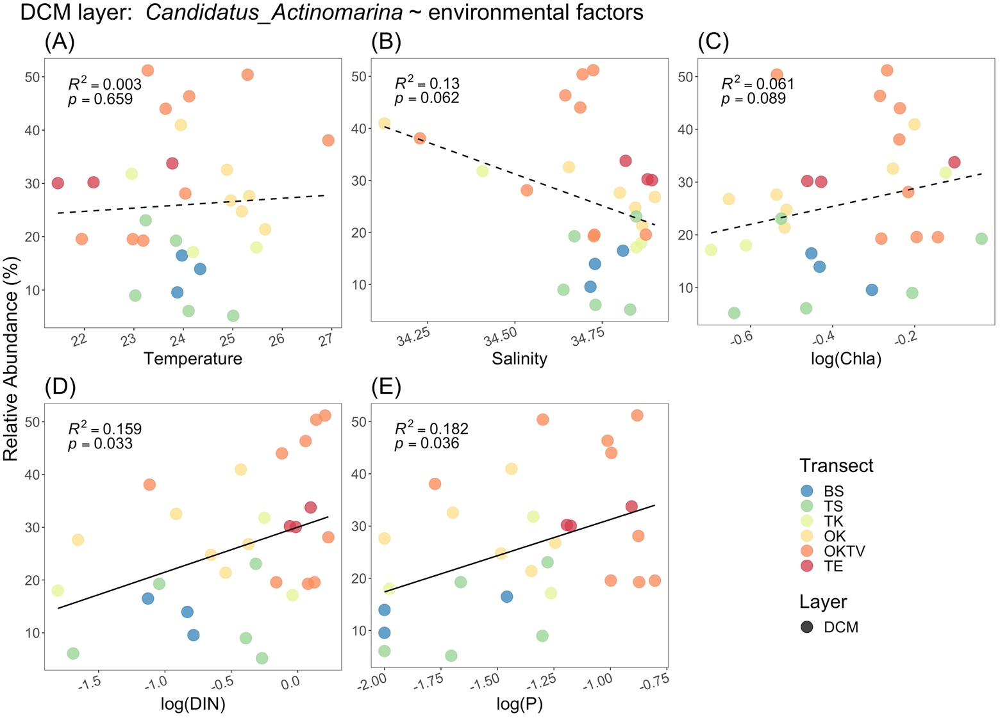

Figure S17. Scatter plots show the relationships between the relative abundance of genus *Candidatus_Actinomarina* versus temperature, salinity, the log-scaled concentration of chlorophyll-a, log-scaled dissolved inorganic nitrogen, and log-scaled phosphate in the surface layer. The color and shape of the dots represent the transect and the layer from which bacterial samples were taken. Solid lines represent significant regressions from the permutated generalized linear model, while dashed lines represent non-significant permutated regressions.

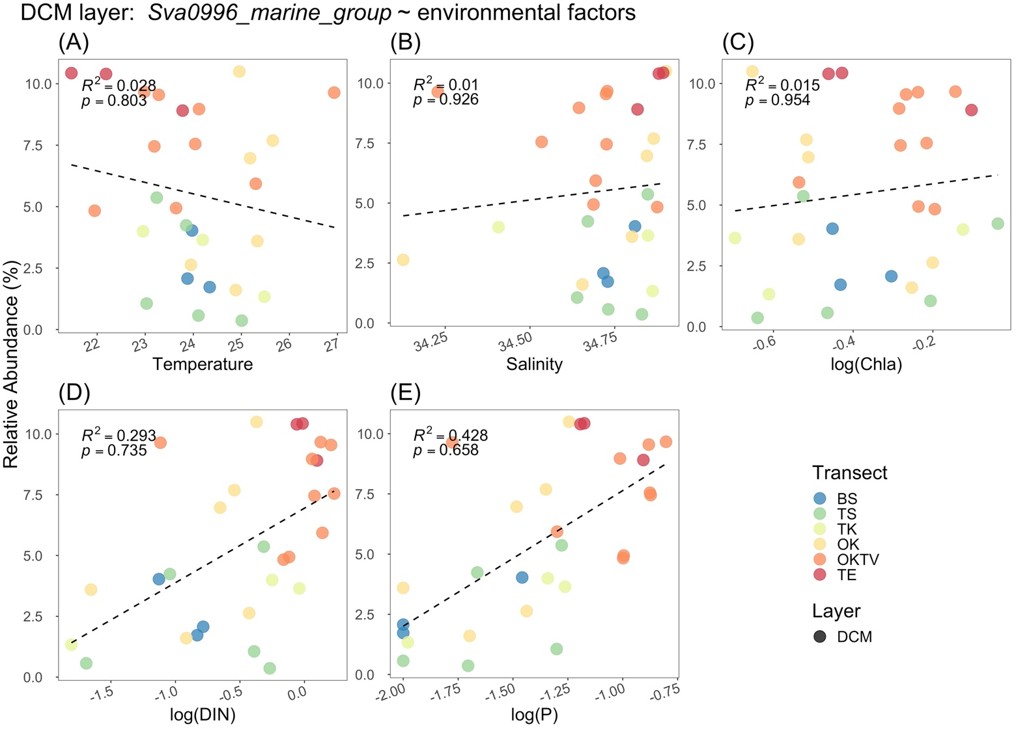

Figure S18. Scatter plots show the relationships between the relative abundance of genus *Sva0996_marine_group* versus temperature, salinity, the log-scaled concentration of chlorophyll-a, log-scaled dissolved inorganic nitrogen, and log-scaled phosphate in the surface layer. The color and shape of the dots represent the transect and the layer from which bacterial samples were taken. Solid lines represent significant regressions from the permutated generalized linear model, while dashed lines represent non-significant permutated regressions.

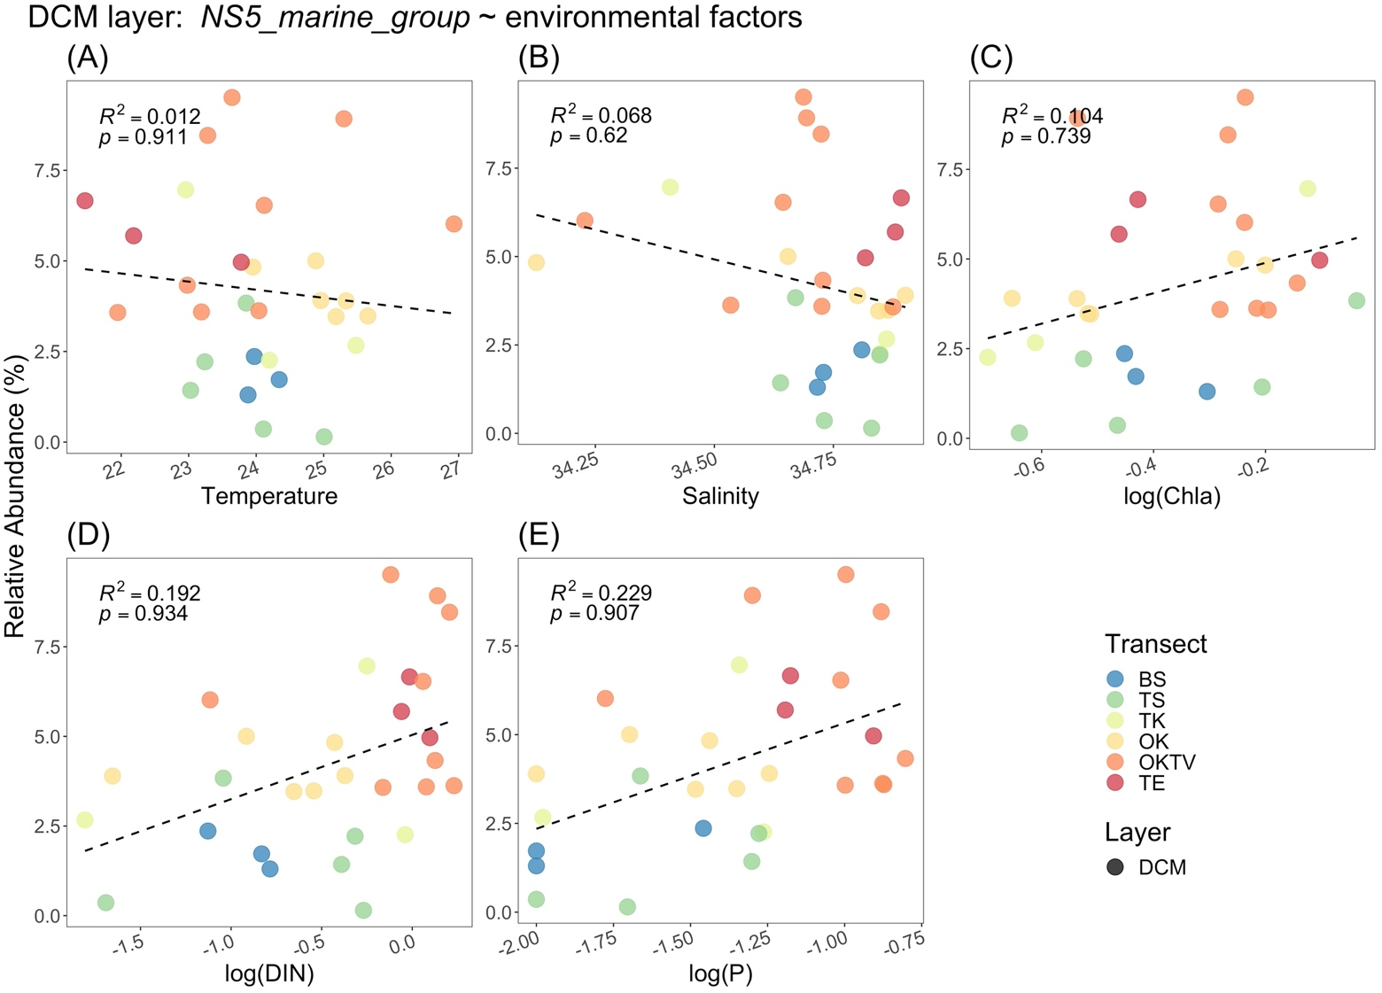

Figure S19. Scatter plots show the relationships between the relative abundance of genus *NS5_marine_group* versus temperature, salinity, the log-scaled concentration of chlorophyll-a, log-scaled dissolved inorganic nitrogen, and log-scaled phosphate in the surface layer. The color and shape of the dots represent the transect and the layer from which bacterial samples were taken. Solid lines represent significant regressions from the permutated generalized linear model, while dashed lines represent non-significant permutated regressions.

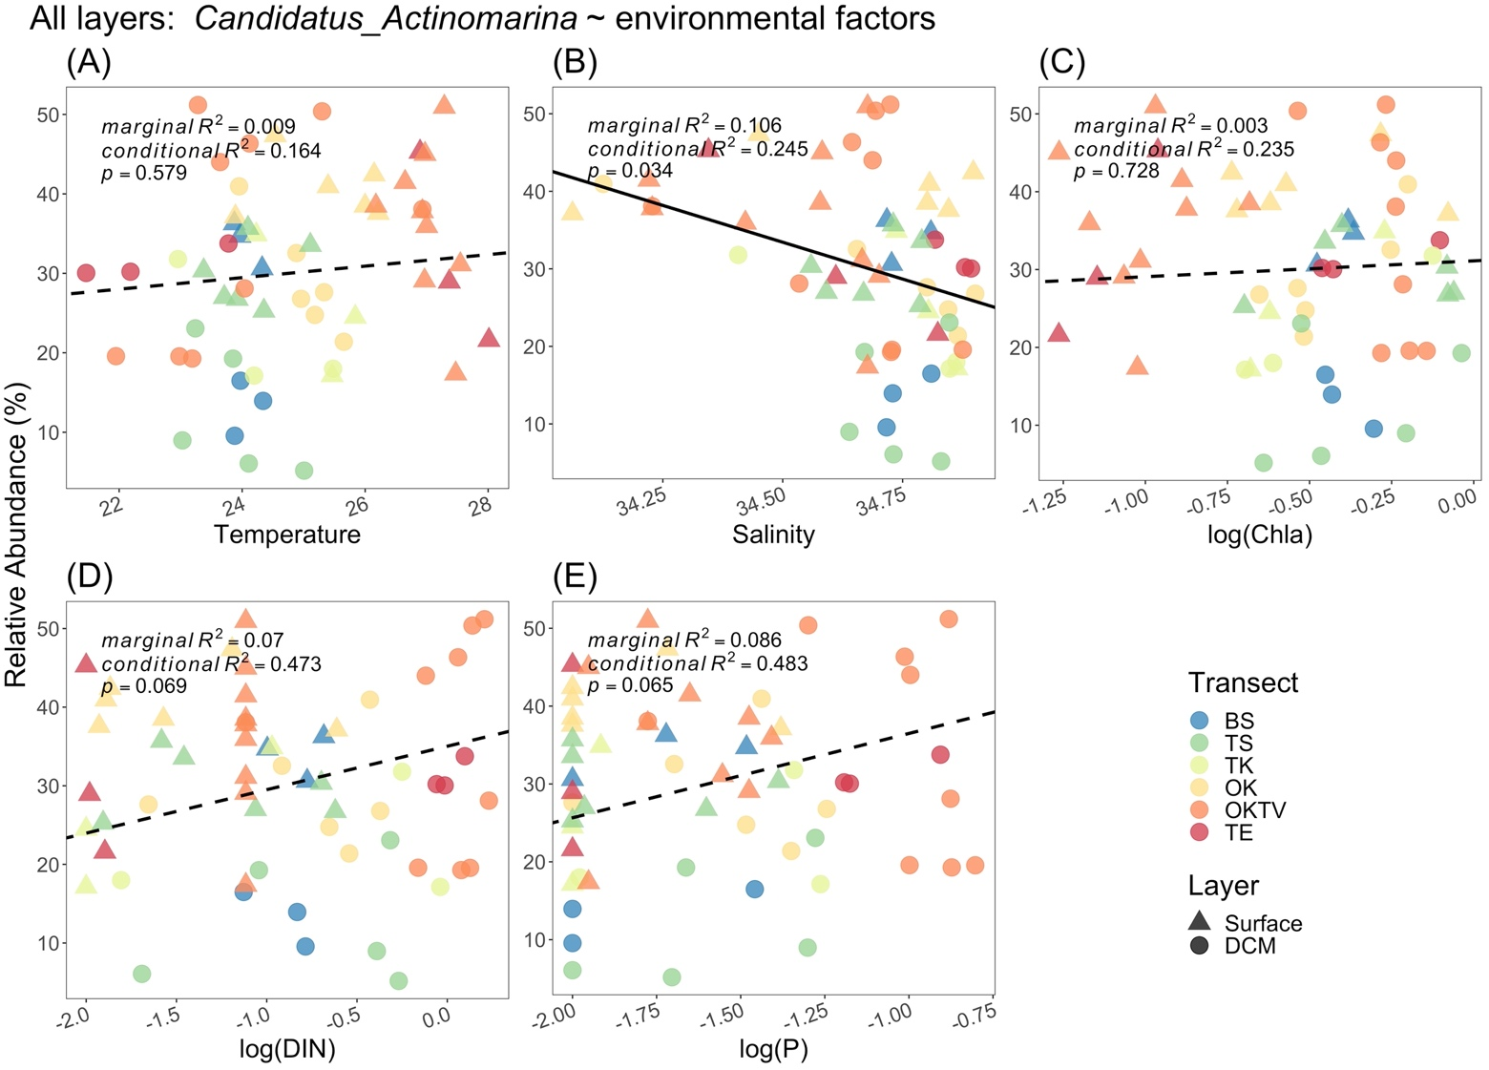

Figure S20. Scatter plots show the relationships between the relative abundance of genus *Candidatus_Actinomarina* versus temperature, salinity, the log-scaled concentration of chlorophyll-a, log-scaled dissolved inorganic nitrogen, and log-scaled phosphate in the surface layer. The color and shape of the dots represent the transect and the layer from which bacterial samples were taken. Solid lines represent significant regressions from the permutated generalized linear model, while dashed lines represent non-significant permutated regressions.

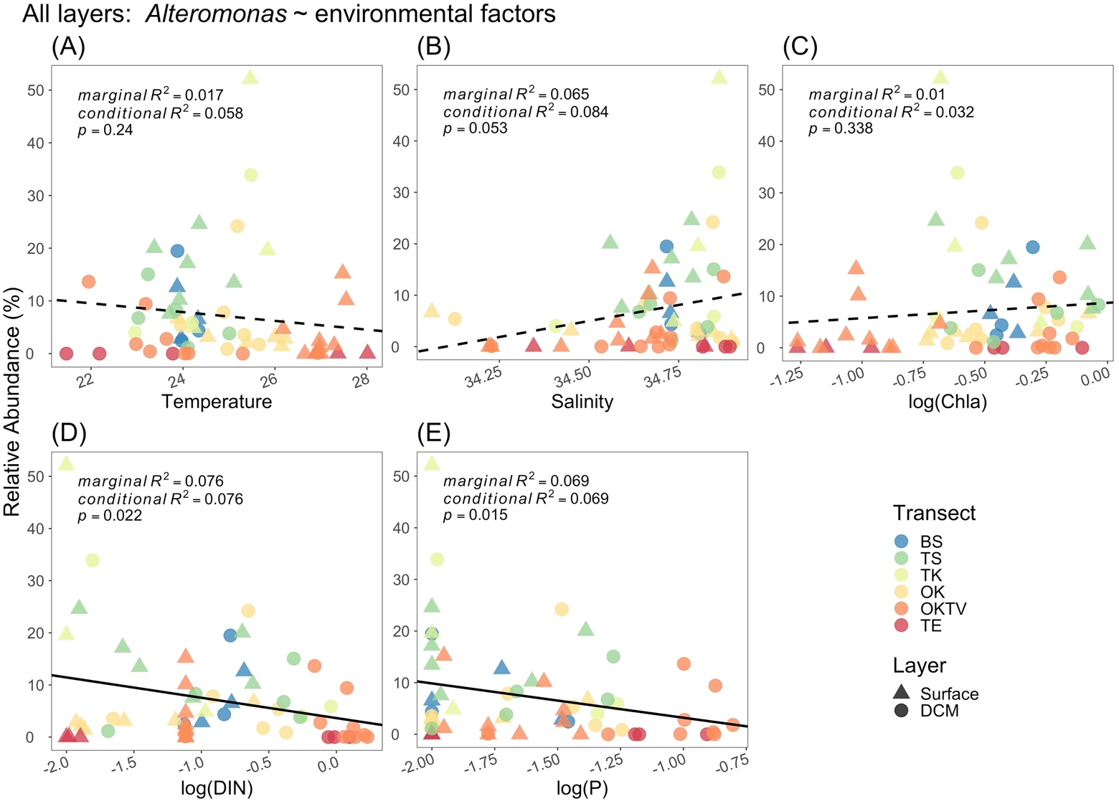

Figure S21. Scatter plots show the relationships between the relative abundance of genus *Alteromonas* versus temperature, salinity, the log-scaled concentration of chlorophyll-a, log-scaled dissolved inorganic nitrogen, and log-scaled phosphate in the surface layer. The color and shape of the dots represent the transect and the layer from which bacterial samples were taken. Solid lines represent significant regressions from the permutated generalized linear model, while dashed lines represent non-significant permutated regressions.

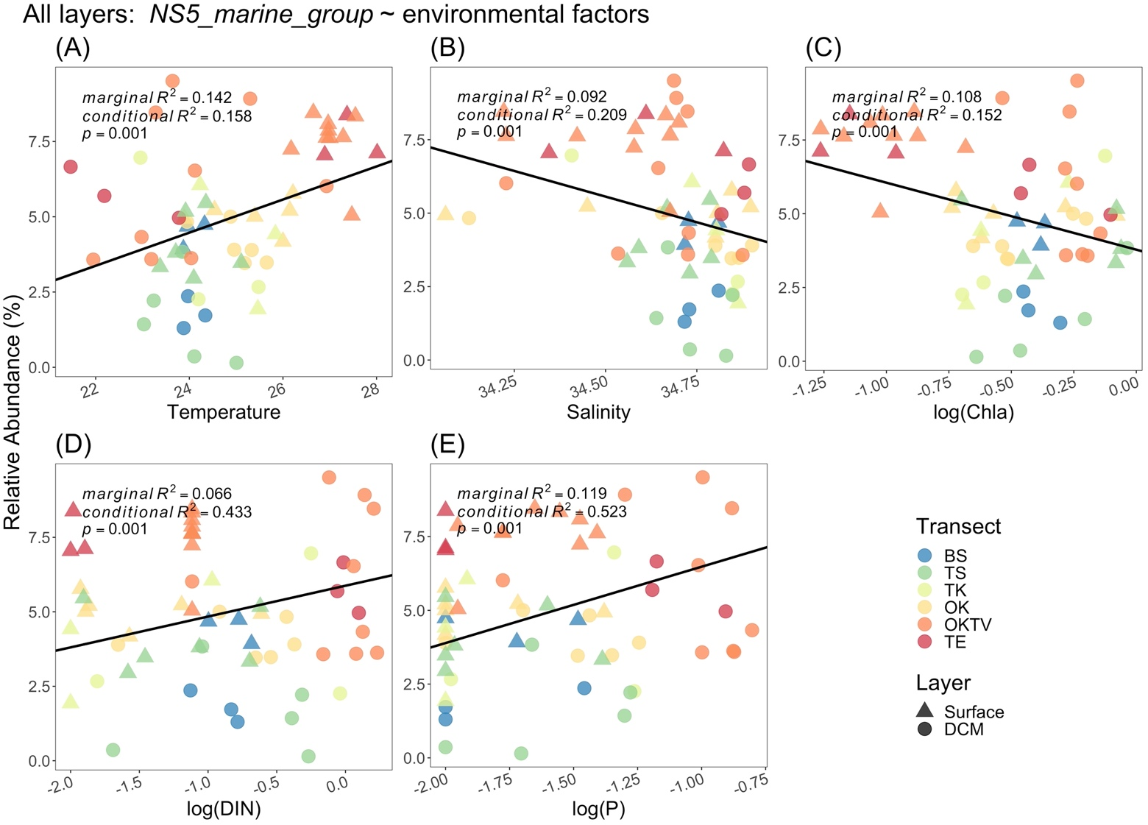

Figure S22. Scatter plots show the relationships between the relative abundance of genus *NS5_marine_group* versus temperature, salinity, the log-scaled concentration of chlorophyll-a, log-scaled dissolved inorganic nitrogen, and log-scaled phosphate in the surface layer. The color and shape of the dots represent the transect and the layer from which bacterial samples were taken. Solid lines represent significant regressions from the permutated generalized linear model, while dashed lines represent non-significant permutated regressions.

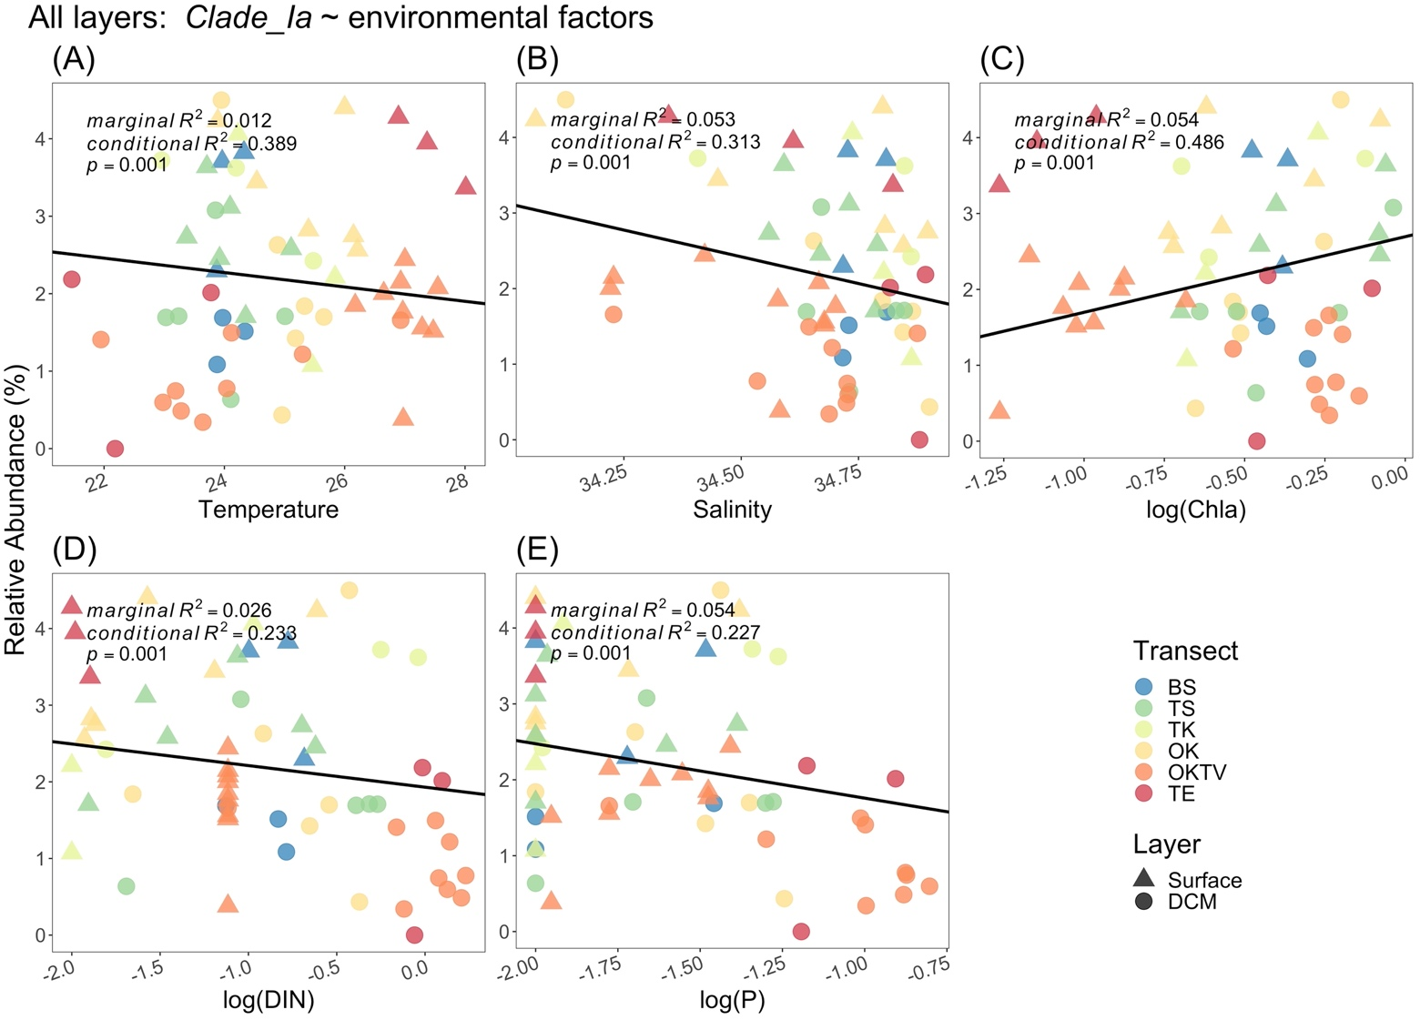

Figure S23. Scatter plots show the relationships between the relative abundance of genus *Clade_la* versus temperature, salinity, the log-scaled concentration of chlorophyll-a, log-scaled dissolved inorganic nitrogen, and log-scaled phosphate in the surface layer. The color and shape of the dots represent the transect and the layer from which bacterial samples were taken. Solid lines represent significant regressions from the permutated generalized linear model, while dashed lines represent non-significant permutated regressions.

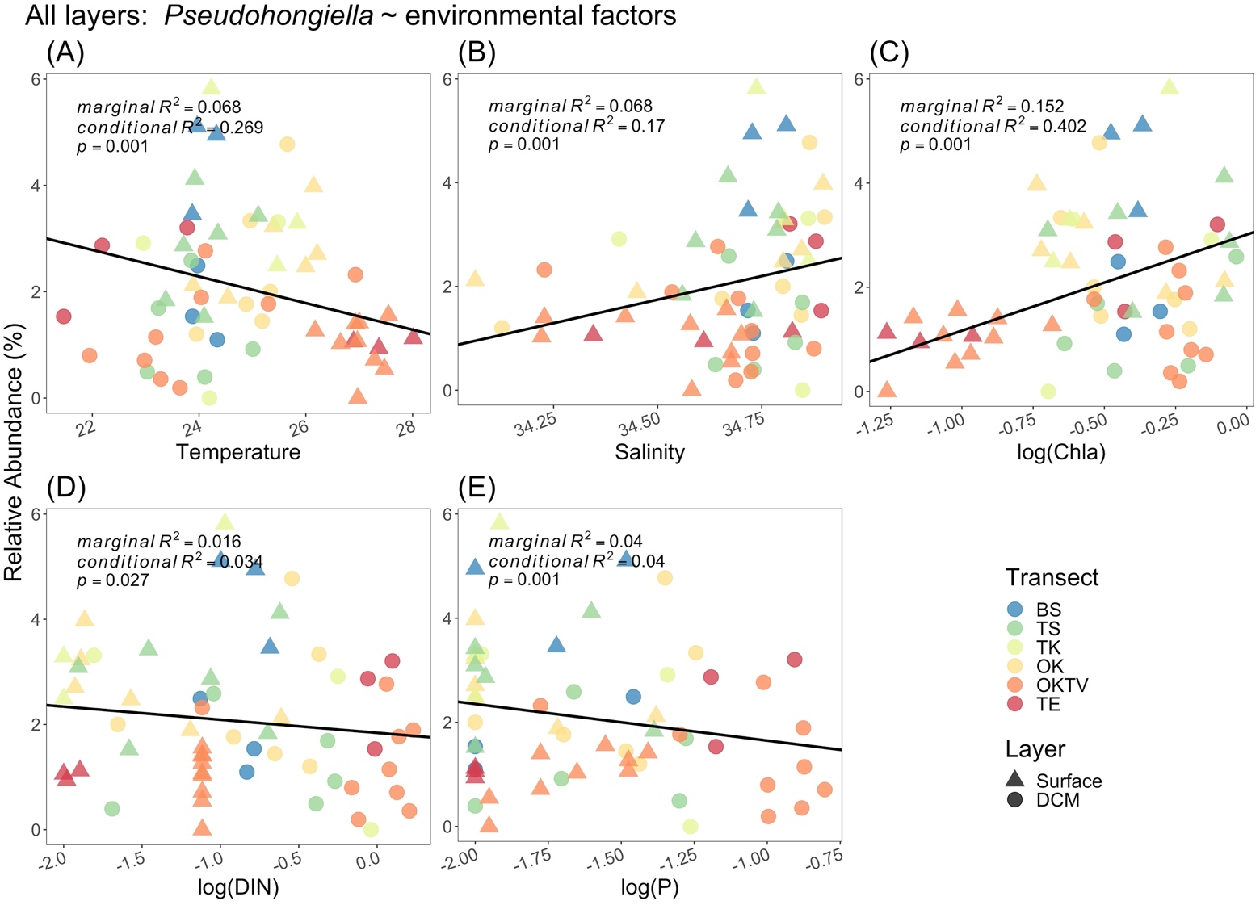

Figure S24. Scatter plots show the relationships between the relative abundance of genus *Pseudohongiella* versus temperature, salinity, the log-scaled concentration of chlorophyll-a, log-scaled dissolved inorganic nitrogen, and log-scaled phosphate in the surface layer. The color and shape of the dots represent the transect and the layer from which bacterial samples were taken. Solid lines represent significant regressions from the permutated generalized linear model, while dashed lines represent non-significant permutated regressions.

Supplement VIII

In this supplement, we visualize the results of generalized linear models (GLMs), or generalized linear mixed effect model (GLMMs) when the surface and the deep chlorophyll-a maximum layer were combined, examining how the log-scaled concentration of chlorophyll-a (*Chla*), log-scaled total dissolved inorganic nitrogen (*DIN*) and log-scaled phosphate (*P*) varied with latitude. Inside the figure, we reported the R2 and p of GLMs or conditional R2, marginal R2, and p of GLMM.

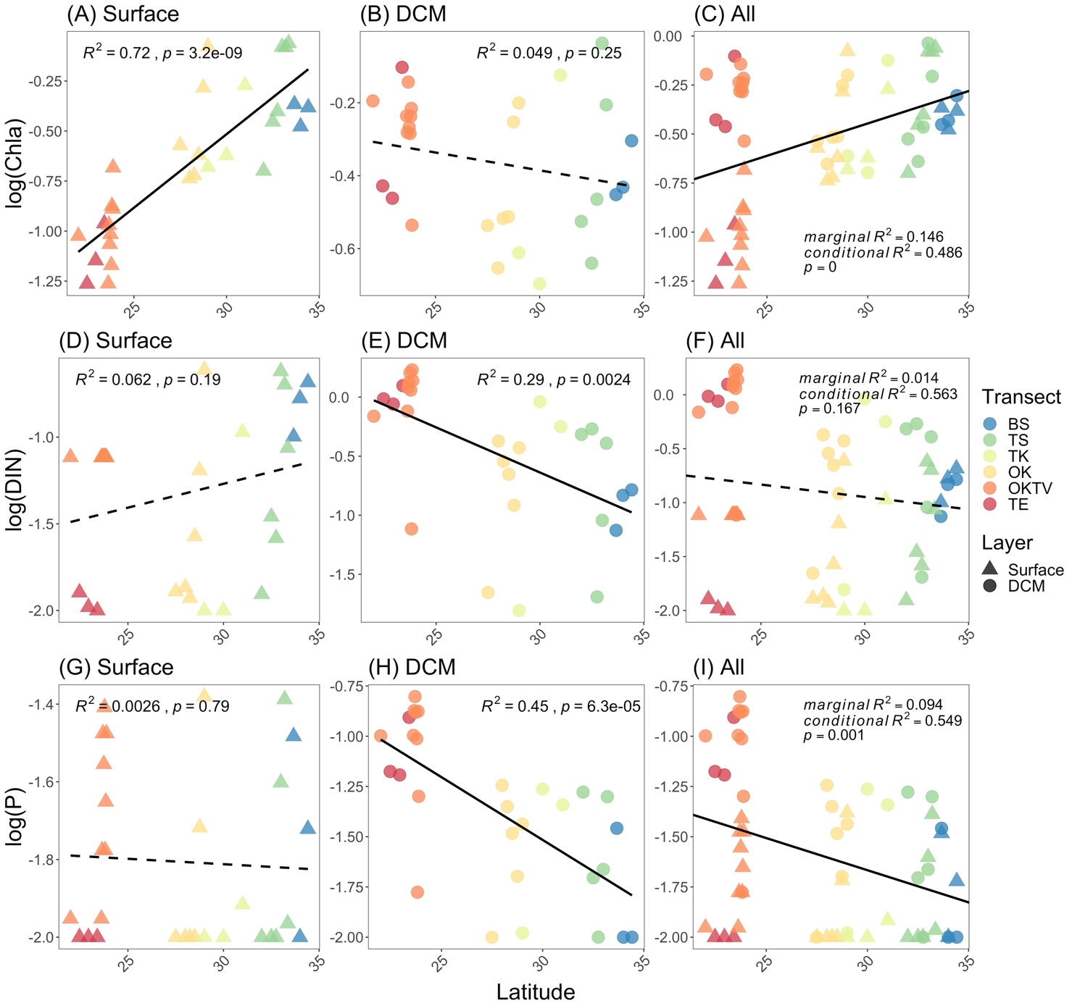

Figure S25. Scatter plots showing the variation of log-scaled chlorophyll-a (panel A to C), log-scaled total dissolved inorganic nitrogen (panel D to F) and log-scaled phosphate (panel G to I) concentrations along the latitude in the surface (panel A, D, and G), deep chlorophyll-a maximum layer (panel B, E, and H) and the combination of two layers (panel C, F, and I). The color and shape of the dots represent the transect and the layer from which bacterial samples are taken.

Supplement IX

In this supplement, we analyze the latitudinal changes of the difference in bacterial ASV composition between the surface versus deep chlorophyll-a maximum (DCM) layer. Toward higher latitude, the bacterial ASV compositions in the two layers appeared to be more similar (cold color dots are closer to each other than those in warm color; Figure 3C). According to the theory of meta-community (Leibold et al. 2004), such a pattern could result from either the more similar environments or closer physical distance between the two layers in higher latitudes than in lower latitudes.

We thus conducted two-way permutational multivariate analyses (PERMANOVA) to partition the variation of bacterial ASV dissimilarity by environmental dissimilarity and physical distance (McArdle and Anderson 2001). The bacterial ASV dissimilarity was the Bray-Curtis dissimilarity between bacterial ASV composition in the surface and DCM layer. For environmental similarity, we first normalized each of the five environmental variables (temperature, salinity, log-scaled concentration of chlorophyll-a, log-scaled dissolved inorganic nitrogen, and log-scaled phosphate) by subtracting the mean from the measurements and then dividing by the standard deviation. The normalized environmental variables were then used to calculate the Euclidean distance as the environmental dissimilarity between the surface and DCM layer. The physical distance between the two layers was also normalized.

In addition to PERMANOVA, we also conducted distance-based redundancy analysis (db-RDA), in which bacterial ASV dissimilarity explained by environmental dissimilarity and physical distance. We then estimated the proportion of variation explained by environmental dissimilarity and physical distance according to the adjusted R2 of db-RDA(Peres-Neto et al. 2006).

According to both the PERMANOVA and the db-RDA methods, we found that pure environmental dissimilarities explained 14.9% (p = 0.005), pure layer distance dissimilarity explained 3.6% (p = 0.001) of the variation of bacterial ASV dissimilarity. The variation explained by both environmental dissimilarity and distance dissimilarity was 25.2%. These results suggest that bacterial ASV composition in two layers is more similar in higher latitudes than in lower latitudes, mainly because the environmental conditions in the two layers are more similar while the physical distance plays a minor role.

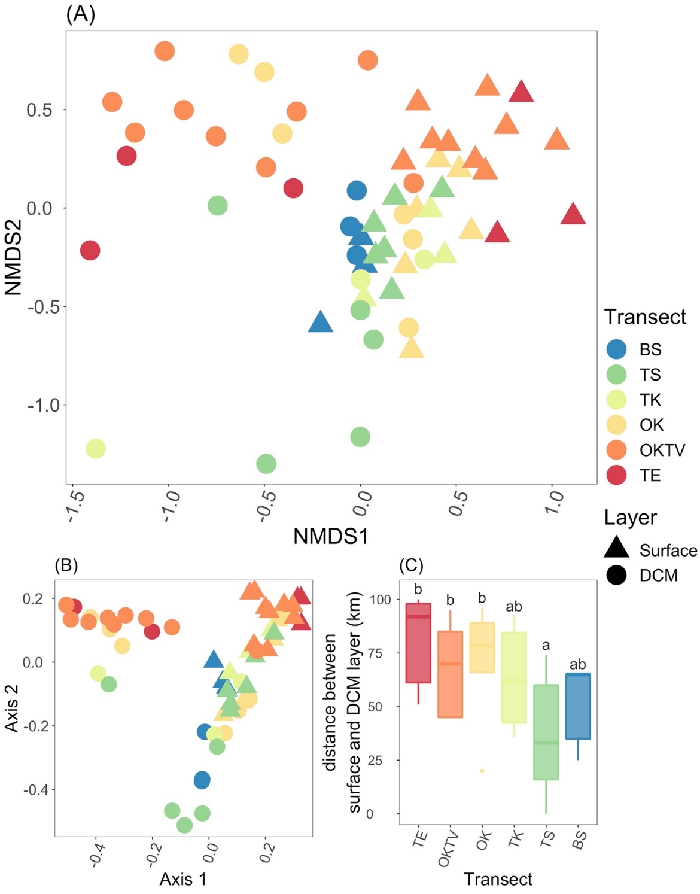Figure S26. The upper panel includes NMDS (PERMANOVA p=0.001, panel A) of both layers’ ASVs. The lower left is the PCoA (panel B) plot of both layers’ ASVs. The ordination color and shape of the dots represent the transect and the layer from which bacterial samples were taken. The lower right panel illustrates the vertical distance between the surface and DCM layer. Letters on the box plots indicate Tukey's honestly significant difference (HSD) post-hoc test results.

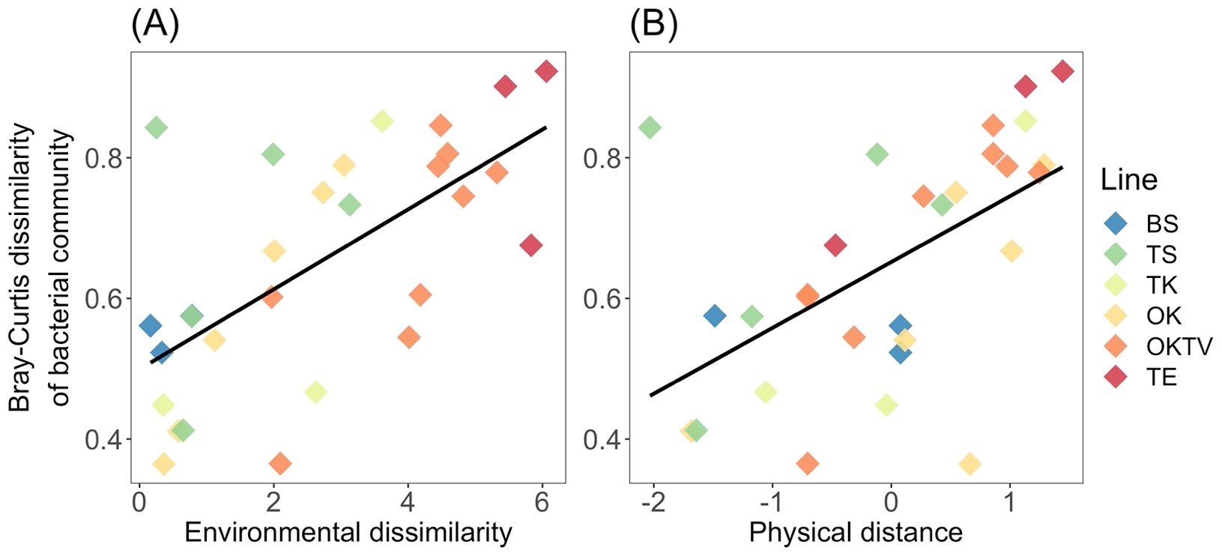

Figure S27. Scatter plots show the relationships between bacterial ASV dissimilarities and environmental dissimilarity (A), and physical distance (B) between the surface and the DCM layer.

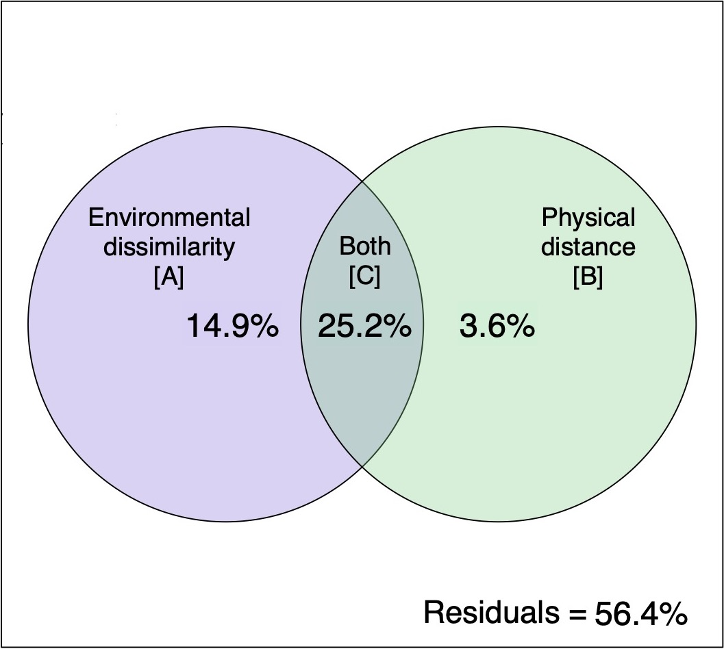

Figure S28. Variation partitioning plot showing the explained variation of bacterial ASV dissimilarities by environmental dissimilarity [A], physical distance [B], and both factors [C].

References

Berry, David, Ben KarimMahfoudh, MichaelWagner, andAlexanderLoy. 2011. “Barcoded Primers Used in Multiplex Amplicon Pyrosequencing Bias Amplification.” *Applied and Environmental Microbiology* 77 (21): 7846–49. https://doi.org/10.1128/AEM.05220-11.

Cai, L, LYe, A HTong, SLok, andTZhang. 2013. “Biased Diversity Metrics Revealed by Bacterial 16S Pyrotags Derived from Different Primer Sets.” *PLoS One* 8 (1): e53649. https://doi.org/10.1371/journal.pone.0053649.

Callahan, B J, P JMcMurdie, M JRosen, A WHan, A JJohnson, andS PHolmes. 2016. “DADA2: High-Resolution Sample Inference from Illumina Amplicon Data.” *Nat Methods* 13 (7): 581–83. https://doi.org/10.1038/nmeth.3869.

Leibold, M. A., M.Holyoak, N.Mouquet, P.Amarasekare, J. M.Chase, M. F.Hoopes, R. D.Holt, et al. 2004. “The Metacommunity Concept: A Framework for Multi-Scale Community Ecology.” *Ecology Letters* 7 (7): 601–13. https://doi.org/10.1111/j.1461-0248.2004.00608.x.

McArdle, Brian H, andMarti JAnderson. 2001. “Fitting Multicariate Models to Community Data A Comment on Distance-Based Reduadancy Analysis.” *Ecology* 82 (1): 290–97. https://doi.org/10.1890/0012-9658(2001)082[0290:FMMTCD]2.0.CO;2.

Peres-Neto, Pedro R, PierreLegendre, StéphaneDray, andDanielBorcard. 2006. “Variation Partitioning of Species Data Matrices: Estimation and Comparison of Fractions.” *Ecology* 87 (10): 2614–25. https://doi.org/10.1890/0012-9658(2006)87[2614:VPOSDM]2.0.CO;2.